Development of High-$β_{P}$ Scenarios towards High-Q on EAST in Support of ITER Steady-state Operation
X. Gong¹, J. Huang¹, B. Zhang¹, X. Zhang¹, M. Li¹, W. Liu¹, C. Pan¹, Y. Hu¹, J. Chen¹, T. Jia¹, N. Yan¹, J. Qian¹, Y. Song¹, B. Wan¹, J. Li¹ and the EAST Team¹
¹Institute of Plasma Physics, Chinese Academy of Sciences, Hefei, 230031, China

Abstract
To provide experimental database and physical basis for ITER steady-state high-fusion-gain ($Q≥10$) operation with full-tungsten first wall, comprehensive high poloidal beta ($β_{P}$) plasma experiments and transport modelling have been carried out on the EAST superconducting tokamak. Fully non-inductive high-$β_{P}$ plasmas sustained by radiofrequency (RF) heating alone (ECRH, LHCD, ICRF) are developed under boron-coated metal wall conditions. A core electron internal transport barrier (electron ITB) is formed to suppress turbulent transport, accompanied by small edge-localized modes (ELMs, $f_{\text{ELM}}>1.0$ kHz), controlled tungsten impurity accumulation, flat core current density profiles with $q_{\text{min}}>1$, and ICRF-mediated suppression of 3/2 tearing modes. TGLF transport simulations reveal that Shafranov-shift-induced $α$-stabilization dominates turbulence suppression inside the ITB. Trapped electron mode (TEM) turbulence governs electron thermal transport within the barrier, while zonal flow shear exerts a regulatory suppression effect on TEM-driven energy loss. High-$β_{P}$ operation significantly elevates bootstrap current fraction $f_{\text{BS}}$, broadens radial current profiles and improves global energy confinement ($H_{98y2}$ up to 1.5). Scans of $q_{95}$ from 5.0 to 6.0 with ITER-like LSN geometry and combined ECRH/ICRF/NBI heating show reduced confinement quality at higher plasma current, together with degraded RF power coupling at altered edge plasma parameters. The EAST high-$β_{P}$ database delivers critical experimental support for ITER’s tungsten wall upgrade and guides future fusion reactor steady-state high-Q scenario design.
Keywords: EAST tokamak; high-$β_{P}$; steady-state operation; electron ITB; trapped electron mode; Shafranov shift; ITER

1. Introduction
ITER’s revised baseline plan shifts the first-wall material from beryllium to full tungsten, introducing new challenges for long-pulse steady-state operation with high fusion gain $Q≥10$. High poloidal beta ($β_{P}$) plasma regimes are widely recognized as a promising route for reactor-relevant steady-state scenarios, featuring three core advantages: low plasma current to mitigate mechanical damage risks, high bootstrap current fraction to reduce external current drive power demand, and large Shafranov shift generating strong $α$-stabilization to suppress core turbulent transport. High-$β_{P}$ research is coordinated across ITPA_IOS multi-tokamak joint experiments, including AUG, DIII-D, KSTAR, WEST and EAST, targeting unresolved physics issues for ITER steady-state operation. EAST, a fully superconducting tokamak with tungsten divertor and flexible multi-RF heating systems, serves as a key testbed to develop ITER-compatible high-$β_{P}$ plasmas with long pulse duration, high confinement and low impurity accumulation. Notable Milestones of EAST: Reproducible 403s H-modes and Breakthrough 1066s High-Confinement Plasma Enabled by High-$β_{P}$ Scenario Development. This paper systematically presents EAST’s latest high-$β_{P}$ experimental progress, transport simulation analysis of electron ITB turbulence physics, parametric scans of safety factor and heating schemes, and future optimization strategies aligned with ITER’s new research plan.

2. Experimental Setup & High-$β_{P}$ Baseline Discharges

2.1 EAST Heating & Wall Conditions
All high-$β_{P}$ experiments rely on three RF heating systems: electron cyclotron resonance heating (ECRH), lower hybrid current drive (LHCD), ion cyclotron resonance frequency heating (ICRF), with optional neutral beam injection (NBI) for ITER-like heating scheme. Two wall conditioning recipes are compared: lithium coating and boronization; boron-coated walls are prioritized for ITER-relevant tungsten compatibility tests in this work. Standard lower-single-null (LSN) divertor geometry consistent with ITER configuration is adopted for parametric scans.
  - Key Baseline High-$β_{P}$ Plasma Parameters
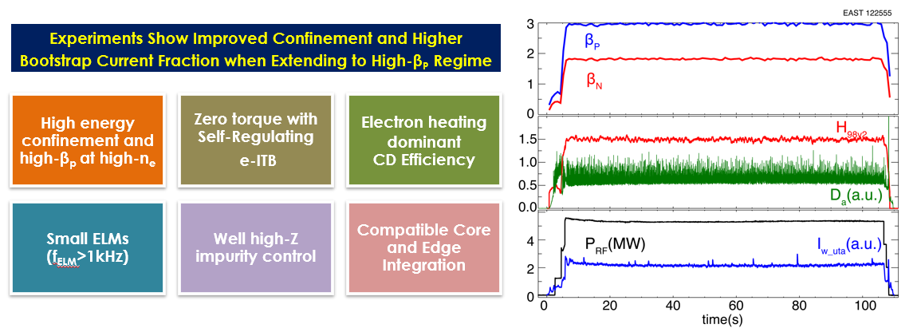
Two representative fully non-inductive high-$β_{P}$ operational regimes are established, 1) High-confinement RF-only regime at $B_{t}=2.5$ T, $q_{95}≈7.0$: sustained for 100 s, $H_{98y2}=1.5$, $β_{P}≈3.0$, $β_{N}≈1.8$, bootstrap fraction $f_{\text{BS}}=50\%$, Greenwald fraction $n_{e}/n_{G}=0.82$, see in figure 1. 2) ITER tungsten-wall compatible regime at $q_{95}=6.0$, $n_{e}/n_{G}=0.65$, $B_{t}=2.5$ T: dominant electron heating yields $H_{98y2}=1.35$, $β_{P}=2.1$, $β_{N}=1.85$. This discharge exhibits a well-defined electron ITB, frequent small ELMs ($f_{\text{ELM}}>2.5$ kHz), suppressed tungsten impurity accumulation, flat core $q$-profile with $q_{\text{min}}>1$, and complete suppression of 3/2 tearing modes via ICRF central heating, shown in figure 2. In high-density high-$β_{P}$ shots, elevated bulk plasma density and $β_{P}$ simultaneously increase $f_{\text{BS}}$, broaden the radial bootstrap current profile, and further elevate global energy confinement performance.
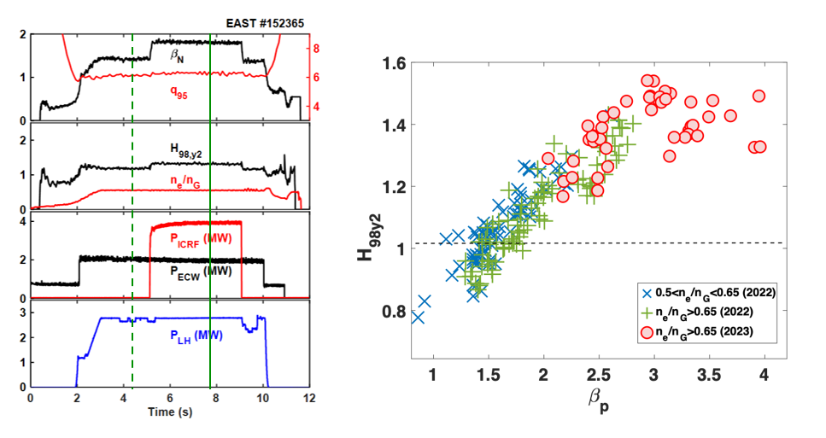
Figure 1. Long pulse Fully Non-inductive High-β_{P} Scenarios operation with a duration of ~100s in RF-heating: V_{L}~ 0, P_{EC}~1.75MW, P_{LH}~2.0MW, P_{IC}~1.6MW.
Figure 2. (a) Development of fully non-inductive high-β_{P} Scenario with Boronization on full metal wall, improved performance during IC heating: V_{loop}~0, P_{LHW}~2.7MW, P_{EC}~2.0MW, P_{IC}~4.0MW, n_{Gr}~0.65, β_{P}~2.1, β_{N}~1.85, H_{98y2} ~1.35, q₉₅~6.0. (b)Energy confinement factor H98y2 versus poloidal beta under varying density.

3. Core Transport Physics of Electron ITB in High-$β_{P}$ Plasmas

3.1 Turbulence Suppression Mechanism from Shafranov Shift
TGLF-SAT0 linear and nonlinear transport simulations are performed against experimental equilibrium profiles of high-$β_{P}$ ITB discharges. Transport simulation results demonstrated α-stabilization induced by Shafranov shift is the dominant factor governing turbulent transport. The Shafranov shift scales positively with $β_{P}$, and $α∝dβ_{P}/dr$; rising $α$ narrows unstable turbulent eigenfunctions and reduces overall turbulent heat flux. Modelling further shows electron turbulent energy flux decreases monotonically with increased $β_{P}$, consistent with core transport reduction observed in experimental electron temperature profiles for $ρ<0.4$.
  - TEM Turbulence and Zonal Flow Shear Regulation
Linear TGLF eigenvalue analysis separates two dominant turbulent regimes across plasma radius: Inside the electron ITB ($ρ<0.4$): trapped electron mode (TEM) is the sole unstable turbulence branch, governing electron thermal energy transport; Outside the ITB ($ρ>0.4$): electron temperature gradient (ETG) modes dominate small-scale electron transport.
The electron thermal ITB is mainly controlled by trapped electron mode (TEM) turbulence, and zonal flow shearing in the ITB region exerts a regulatory effect on TEM-induced energy transport. While E×B shear flow shows weak direct impact on energy transport, the combined effect of Shafranov shift $α$-stabilization and zonal flow shear forms the dual barrier mechanism sustaining low core electron transport and high $T_{e}$ gradient.

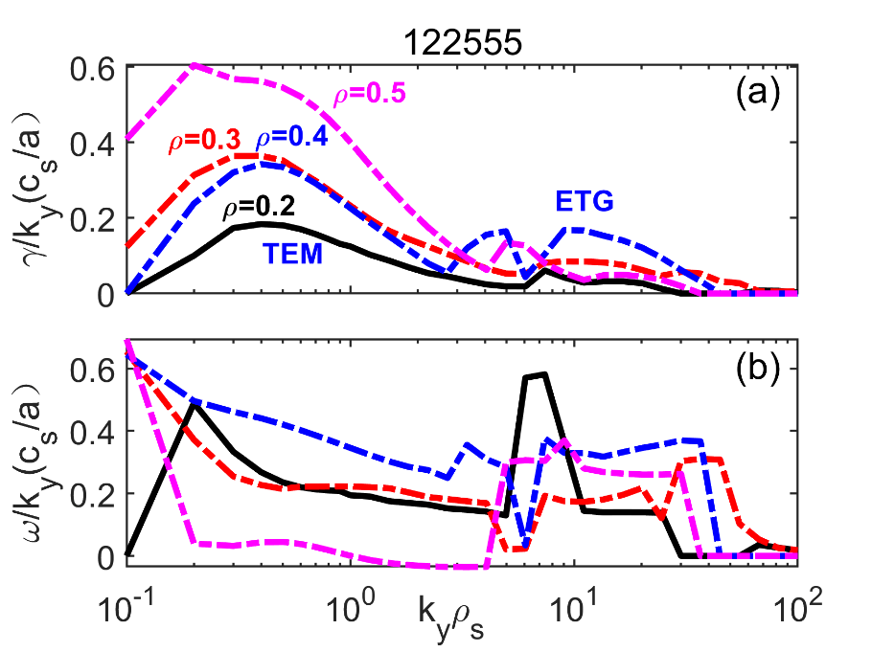
Figure 3. Linear growth rates of TEM and ETG turbulence modes as a function of normalized minor radius $ρ$ in high-$β_{P}$ electron ITB plasma.

4. Parametric Scans of ITER-Relevant High-$β_{P}$ Scenarios
  - Safety Factor $q_{95}$ Scanning with ITER-like Heating Combinations
To match ITER’s moderate $q_{95}$ operational window, plasma current scans cover $q_{95}=5.0-6.0$ under LSN geometry with combined ECRH, ICRF and NBI heating (no LHCD, replicating ITER’s baseline heating mix). Two primary trends are identified: 1) Global confinement factor $H_{98y2}$ degrades from 1.35 down to 1.1 as plasma current rises (lower $q_{95}$); 2) Edge scrape-off layer (SOL) electron density drops significantly with increased plasma current, modifying wave accessibility for RF heating systems. Edge plasma profiles strongly influence the coupling and power absorption efficiency of both LHCD and ICRF. Lower SOL density at low $q_{95}$ reduces LHCD wave coupling, while SOL temperature modification alters collisional power loss for ion cyclotron waves.
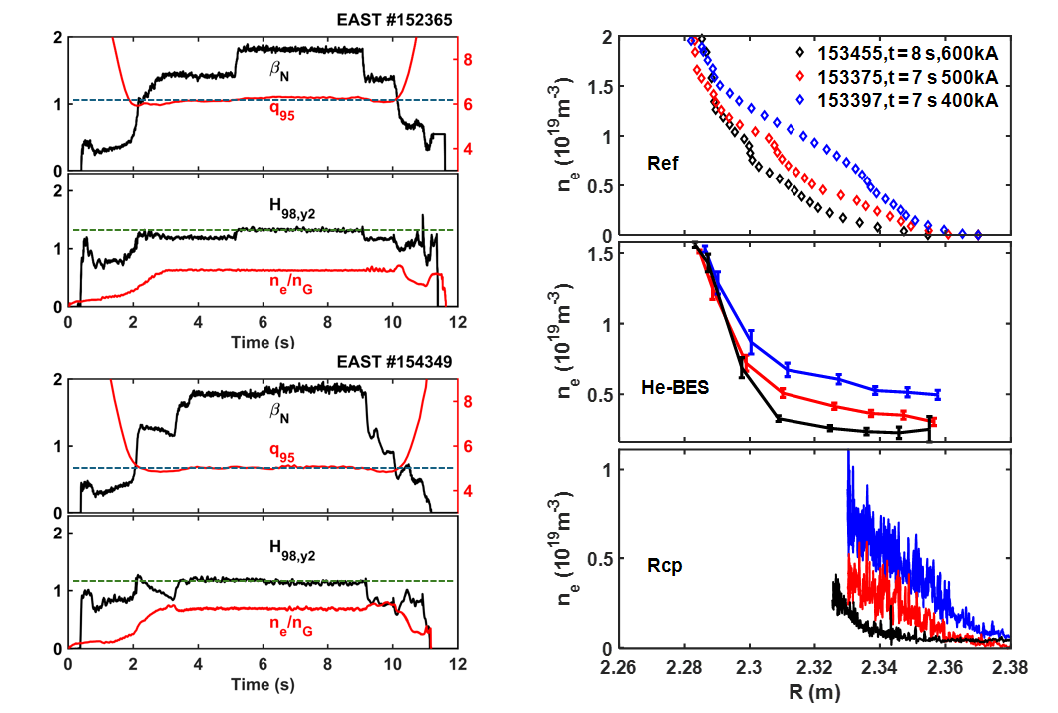
Figure 4. Left: High-β_{P}p plasma operation at q₉₅=6.2 5.0 for extension fusion performance towards high-Q, same RF power injection at density n_{e}/n_{G}~0.6, H_{98y2} decreased as plasma current increased Right:Radial profiles of SOL electron density and temperature under different plasma current ($I_{p}$) / $q_{95}$ conditions.

4.2 Current Profile Broadening for Enhanced Bootstrap Fraction
Off-axis early ECRH deposition during plasma current ramp-up and off-axis LHCD injections produce broader radial current density profiles. Broader $j(r)$ reduces internal inductance $l_{i}$, weakens core magnetic shear, raises $β_{P}$, and further boosts bootstrap current fraction $f_{\text{BS}}$. ICRF central heating additionally broadens the bootstrap current profile by elevating core electron temperature gradients, which counteracts peaked ECCD current profiles. For discharges with $q_{\text{min}}>2$, low-order NTMs (3/2 and 2/1 tearing modes) are fully stabilized, avoiding core confinement degradation.
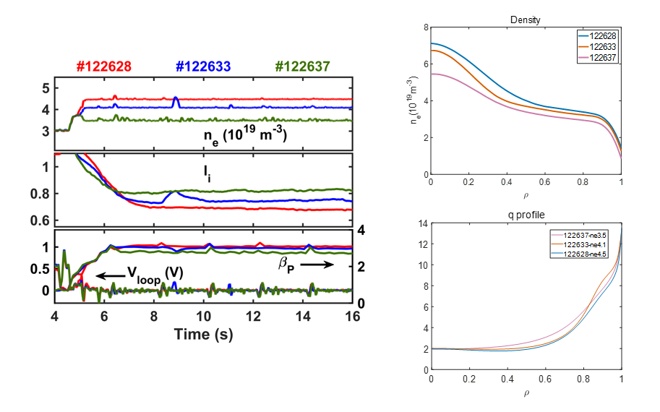
Figure 5. Broad Current Profile by Early EC Heating and off-axis LHCD
at High Density Sustained Fully Non-inductive High-β_{P} Scenarios.

4.3 Wall Conditioning Impact on Heating Efficiency & Confinement
Lithium wall coating improves LHCD current drive efficiency by a factor of 1.35 relative to boronization, driven by higher SOL electron temperature which mitigates parasitic density-interaction power loss. ECRH confinement performance shows weak sensitivity to wall materials, but boronized high-$β_{P}$ plasmas suffer ~10–15% lower $H_{98y2}$ compared with lithium-conditioned shots, a critical consideration for ITER’s full-tungsten boron wall conditioning strategy.
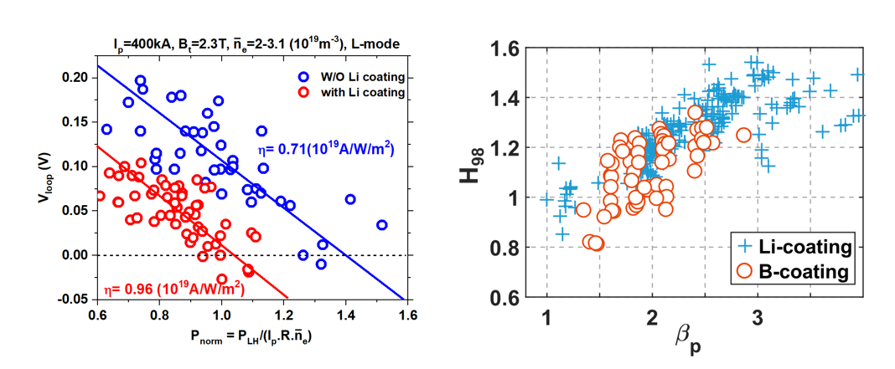
Figure 6. (a) Comparison of LHCD current drive efficiency, (b) normalized confinement $H_{98y2}$ between lithium coating and boronization wall conditioning.

5. Challenges and Near-Term EAST Optimization Roadmap
  - Outstanding Physics Challenges
Several unresolved issues limit high-$β_{P}$ high-Q steady-state performance on EAST and translate to open risks for ITER: 1) Robust formation of wide-radius full-channel ITBs compatible with tungsten impurity control; 2) Helium ash and tungsten impurity transport under long-pulse high-$β_{P}$ conditions; 3) Edge pedestal and ELM dynamics under detached divertor plasma; 4) Resistive wall mode stability limits at low plasma rotation typical of fully non-inductive RF-only discharges; 5) Predictive modelling capability for ITB radial location dependence on collisionality and heating mix.
  - Near-Term Experimental Optimization Plans
Based on the parametric scan results, EAST’s upcoming high-$β_{P}$ campaign targets ITER-matched steady-state high-Q scenarios with four key optimizations: a) Adopt moderate safety factor $q_{95}≈5.0$, consistent with ITER baseline steady-state operation; b) Deploy ITER-standard heating configuration (ECRH + ICRF + NBI) without LHCD to replicate ITER’s current drive composition; c) Enhance ion heating power to adjust $T_{i}/T_{e}$ ratio, raising ion thermal confinement and fusion reactivity; d) Optimize off-axis ECRH/LHCD to maximize current profile broadening, targeting $q_{\text{min}}>2$ to form wide full-channel ITBs and eliminate low-order tearing modes. Additional wall-conditioning tests will evaluate new boronization precursors ($B_{2}D_{6}$) to recover confinement lost under boron-coated tungsten walls, reducing the performance gap relative to lithium conditioning.

6. Conclusions
Systematic high-$β_{P}$ plasma experiments and TGLF transport modelling on EAST deliver critical physical insights for ITER’s tungsten-wall steady-state high-Q operation. Fully non-inductive RF-driven high-$β_{P}$ discharges achieve high confinement ($H_{98y2}$ up to 1.5), high bootstrap fraction ($f_{\text{BS}}>50$), stable electron ITBs and mitigated ELM activity. Transport simulations quantitatively confirm Shafranov-shift $α$-stabilization as the dominant turbulence suppression factor, with TEM turbulence governing core electron thermal transport and zonal flow shear providing secondary regulatory suppression of TEM heat flux.
Parametric scans of $q_{95}$, heating schemes and wall conditioning quantify confinement degradation at lower $q_{95}$ and boron-wall induced performance losses, establishing clear optimization directions for future long-pulse campaigns. The EAST high-$β_{P}$ experimental database provides direct technical support for ITER’s revised tungsten-first-wall research programme and establishes a scalable physical framework for steady-state high-performance scenarios in commercial fusion power plants.

Acknowledgements
This work is supported by the National MCF Energy R&D Program of China (2022YFE03050000), and ITPA IOS joint research activities. The authors acknowledge the TGLF modelling team for transport simulation support and EPS 2026 conference organizers for presentation opportunity.

References
[1] Garofalo A M et al, Fusion Eng. Des. 89 (2014) 1088
[2] Huang J et al, Phys. Plasmas 30 (2023) 062504
[3] Gong X et al, Nucl. Fusion 64 (2024) 116026
[4] Loarte A, Plasma Phys. Control. Fusion 67 (2025) 054002
[5] Qian J P et al, Phys. Plasmas 28 (2021) 042508
[6] Pitts R A et al, Nat. Mater. Eng. 2 (2019) 928

