The FreeGSNKE Pulse Design Tool: a Python-based, open-source framework for in-silico scenario and control design in tokamak plasmas
K. Pentland¹, N. C. Amorisco¹, A. Ross², P. Cavestany², T. Nunn¹, A. Agnello², G. K. Holt¹, G. McArdle¹, C. Vincent¹, J. Buchanan¹, S. J. P. Pamela¹
1 United Kingdom Atomic Energy Authority, Culham Campus, Abingdon, UK
2 STFC Hartree Centre, SciTech Daresbury, Warrington, UK
Motivation
In magnetic confinement fusion, reliable Plasma Control Systems (PCS) are essential for safely initiating, sustaining, and reproducing high-performance tokamak plasma scenarios. In this work, we focus on magnetic shape control, which can be continuously adjusted throughout a discharge by applying voltages to the poloidal field (PF) coils [1]. Developing and validating magnetic controllers directly on a tokamak can, however, be iteratively expensive and time consuming. Pulse Design Tools (PDTs), in which a virtual PCS is combined with a plasma simulator, enable in silico scenario and control design, parameter calibration, and safety limit testing before experimental execution. Several PDTs have been successfully used to support tokamak experiments – including, but not limited to, TokSys [2], MEQ [3], and NICE [4] – differing widely in their physics capabilities and accessibility.
Here, we present the FreeGSNKE Pulse Design Tool (FPDT), an open-source, Python-based framework that couples the FreeGSNKE evolutive equilibrium solver [5] with a customisable, modular virtual PCS [6]. It enables predictive scenario design and virtual testing of advanced plasma configurations, new control algorithms, and the impact of diagnostic uncertainties on plasma evolution and performance. Although inspired by the MAST-U PCS architecture [7], the virtual PCS is inherently machine-independent, supporting the implementation of diverse control algorithms tailored to specific tokamaks.
The framework
The FPDT consists of two coupled components: the FreeGSNKE evolutive simulator and a new virtual PCS class (see Figure 1). Given a tokamak geometry (PF coils, passive conductors, and limiter), an initial Grad-Shafranov (GS) equilibrium, and user-defined reference waveforms and controller settings, the two components exchange equilibrium measurements and PF coil voltages at each simulation timestep in a closed loop.
Using a combination of feedback (FB) and feedforward (FF) controllers, the virtual PCS uses simulated diagnostic measurements (e.g. PF coil currents, shape parameters, plasma position) to calculate PF coil voltages, strictly adhering to machine safety limits on currents and voltages. Using these voltages, the simulator then evolves the PF coil currents, passive conductor currents, and total plasma current according to the circuit and plasma equations while simultaneously satisfying the GS equation [5]. In the absence of self-consistent profile evolution, the simulator also requires plasma current density profile parameters and resistivity at each step.
Validation on MAST-U discharge
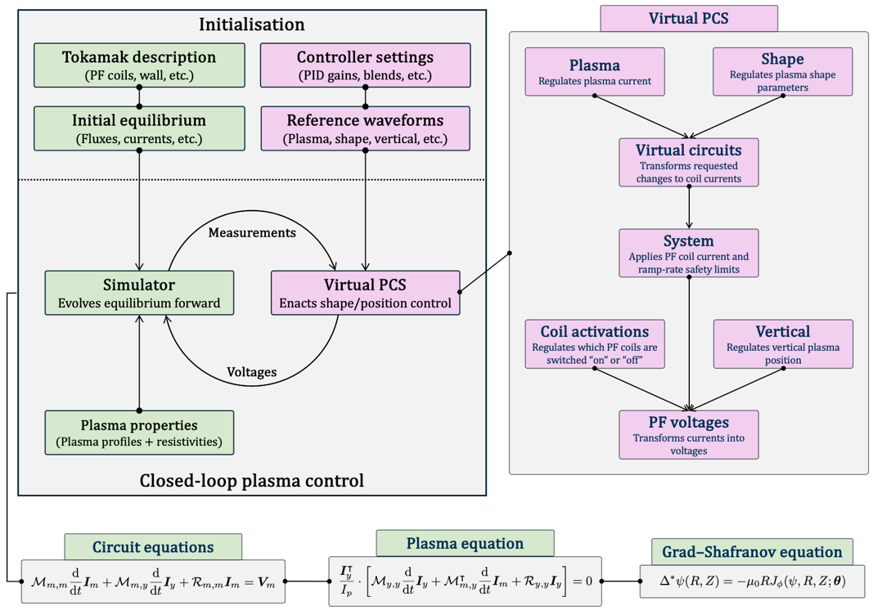
To validate the accuracy of the FPDT, we re-simulate the flat-top phase of MAST-U shot 50364, a double-null $750$kA Ohmically heated plasma, originally designed using the Tokamak Exhaust Designer [8] to generate an X-divertor plasma (see upper right panels in Figure 2). We initialise the MAST-U geometry with calibrated (offline) PF coil resistances and inductances and define an initial GS equilibrium at $t=0.2$s using the EFIT++ reconstruction data.
Figure 1: Schematic of the FPDT’s closed-loop architecture. The left panel depicts the overall framework and the interaction between the simulator (green) and the virtual PCS (purple). The right panel details the structure of the virtual PCS and how individual controllers interact. The three equations at the bottom are solved together at each time step by the simulator using voltages determined by the virtual PCS.
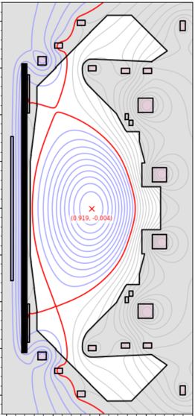
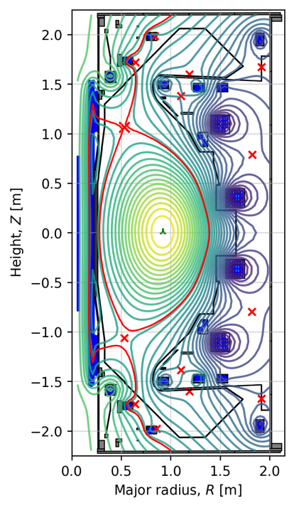
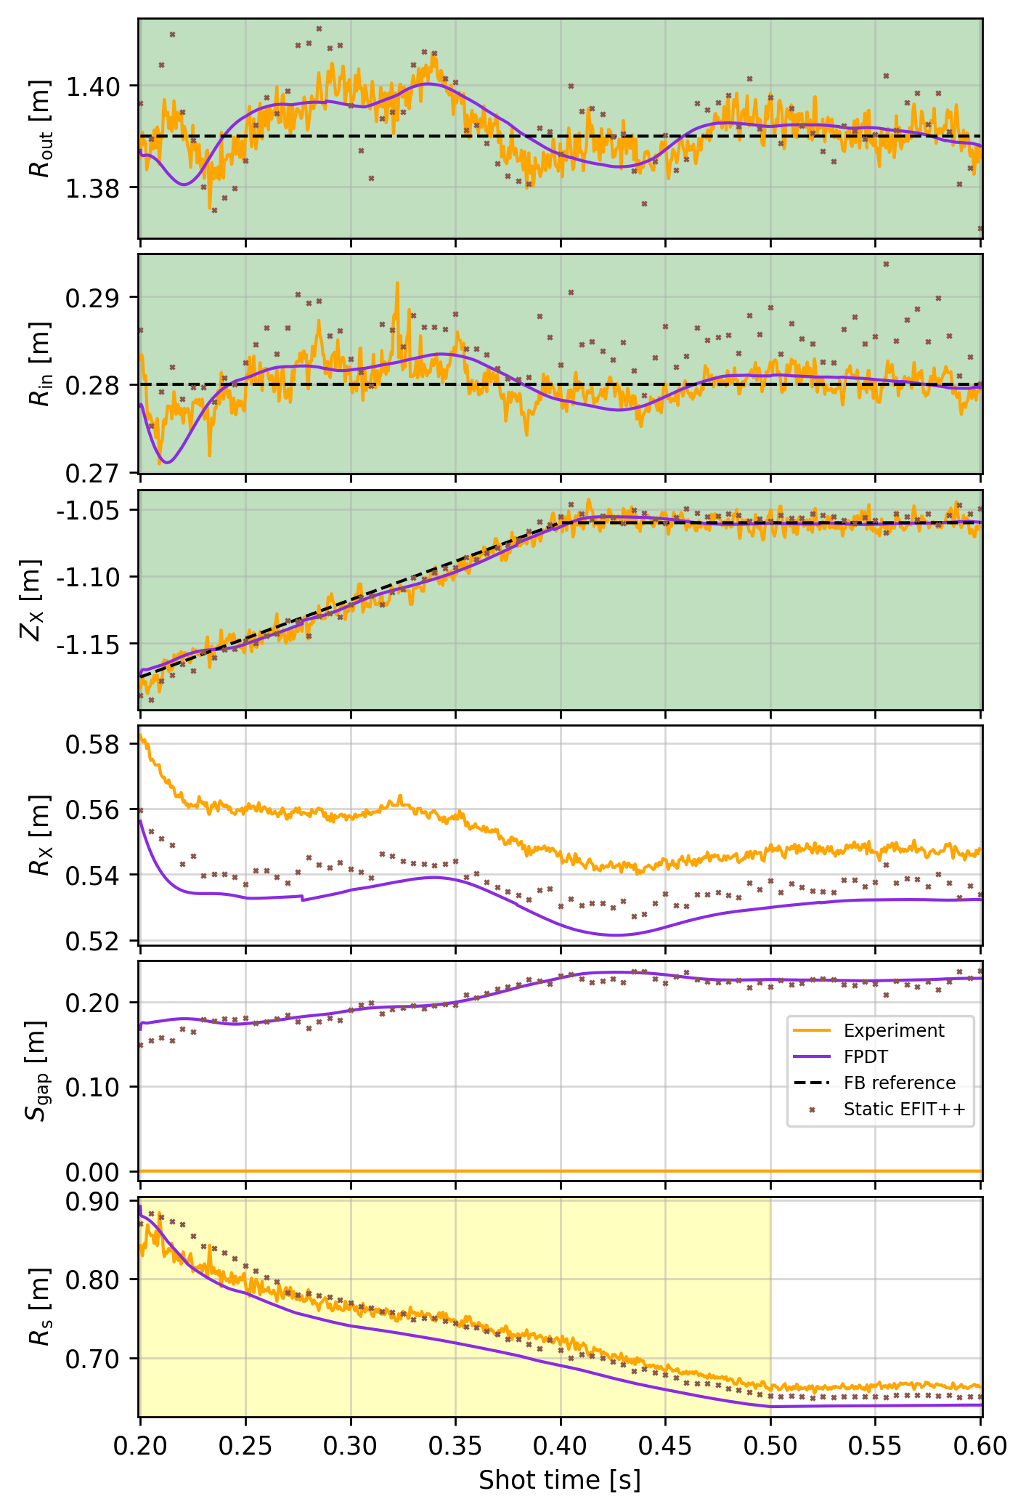
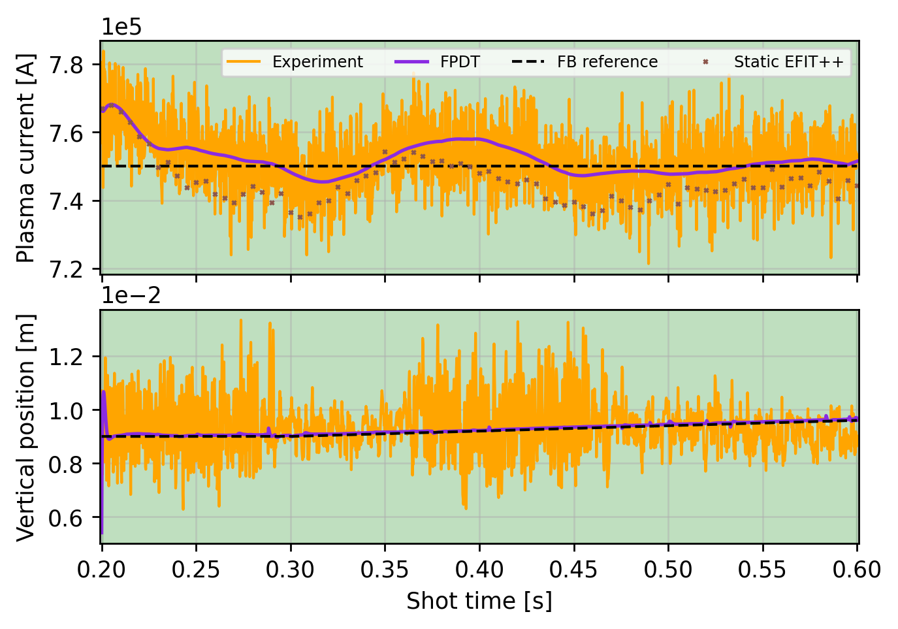
The lower left and right-hand panels in Figure 2 illustrate how the FPDT sustains and controls the evolution of plasma current, vertical position, and key shape parameters – including the midplane radii (R_{in} and R_{out}), lower X-point position (R_{x} and Z_{x}), squareness gap (S_{gap}), and lower outer strikepoint (R_{s}) – using identical input waveforms and control settings as in the real discharge. Simulated results (purple) show strong agreement with both real-time experimental measurements (orange) and static EFIT++ reconstructions (brown crosses), with the FPDT outputs falling well within the margin of uncertainty between the two. Although not shown here, PF coil voltages and currents also match experiment, falling well within the safety limits applied by the virtual PCS with small divergences accumulating over time that suggest further machine calibration (with vacuum magnetics) could be required. Note also that S_{gap} was not measured in real time for this shot.
Figure 2: Simulation results produced by the FPDT for MAST-U shot 50364. The top left panel displays the poloidal flux contours from the FPDT and an EFIT++ reconstruction at $t=0.55$s. The lower left panel displays the evolution the plasma current and vertical position over time, comparing the experimental measurements (orange), the FPDT (purple), the FB reference waveforms (dashed black), and static EFIT++ reconstructions (brown crosses). The right panel shows the evolution of six key shape parameters over time. Green shading indicates when FB control is on, yellow when FF control is on, and white when no control is used.
EFIT++
FPDT
Using a 65 x 65 computational grid and a simulation timestep of $0.2$ms, these results were generated in approximately 5 minutes with a standard MacBook Pro, Apple M2 Pro chip, 16GB RAM with no specialist parallelisation or hardware. This makes the FPDT suitable for iterative scenario design, running between shots during experimental campaigns.
Discussion
Following this validation work, the FPDT has already been successfully used to develop several challenging configurations and highly shaped plasma scenarios in the fifth MAST-U campaign (2025/26). It serves as a testbed for classical and new AI-based control schemes, and future work will aim to extend the simulation window to the ramp-up phase and incorporate different current diffusion models. With this addition to the FreeGSNKE open-source suite, we aim to foster greater reproducibility and collaboration across the plasma modelling and control community.
Acknowledgements
This work was funded by the Fusion Computing Lab collaboration (between UKAEA and STFC Hartree) and the EPSRC Energy Programme (EP/W006839/1).
References
- M. Ariola and A. Pironti. Magnetic control of tokamak plasmas. Advances in Industrial Control. Springer International Publishing, 2016. doi: 10.1007/978-3-319-29890-0.
- D. A. Humphreys et al. DIII-D integrated plasma control solutions for ITER and next-generation tokamaks. Fusion Engineering and Design, 83(2):193-197, 2008. doi: 10.1016/j.fusengdes.2008/01/012.
- F. Carpanese. Development of free-boundary equilibrium and transport solvers for simulation and real-time interpretation of tokamak experiments. PhD Thesis, EPFL, 2021.
- R. Nouailletas et al. Development of a flight simulator for the WEST plasma and control system. Fusion Engineering and Design. 219:115299, 2025. doi: 10.1016/j.fusengdes.2025.115299.
- N. C. Amorisco et al. FreeGSNKE: a python-based dynamic free-boundary toroidal plasma equilibrium solver. Physics of Plasmas, 31(4):042517, 2024. doi: 10.1063/5.0188467.
- K. Pentland et al. The FreeGSNKE Pulse Design Tool (FPDT): a computational framework for evolutive plasma scenario and control design. 2026. arXiv: 2603.28513.
- G. J. McArdle et al. Integrated real-time control on the MAST Upgrade tokamak. In 29th IAEA Fusion Energy Conference (FEC), 2023. doi: UKAEA scientific publications.
- O. P. Bardsley et al. The Tokamak Exhaust Designer: a new tool for enhanced divertor control on MAST-U. In Proceedings of the 51st EPS Conference on Controlled Fusion and Plasma Physics, page O2.032, 2025.

