Operational status and current capabilities of the ELIMAIA-ELIMED experimental platform
F. Grepl¹*, M. Tryus¹, F. Schillaci¹, H. Lefebvre¹, V. Istokskaja¹, A. Velyhan¹, V. Kantarelou¹, P. Bláha¹, M. Greplová Žáková¹, N. Gamaiunova¹, T. Chagovets¹, P. Szotkowski¹, J. Novák¹, L. Jarboe¹, D. Peceli¹, J. Černý¹, M. Cuhra¹, J. Sedmidubská¹, B. Lopushanska¹, A. Sarafis¹, J. Moučka¹, J. Šabata¹, G.A.P. Cirrone², D. Margarone¹, B. Rus¹ and L. Giuffrida¹
1The Extreme Light Infrastructure ERIC - ELI Beamlines Facility, Za Radnicí 835, 252 41 Dolní Břežany, Czech Republic
² INFN - Laboratori Nazionali del Sud, Via S. Sofia 62, 95123 Catania, Italy

The Extreme Light Infrastructure (ELI) is the world's largest high-power laser research infrastructure. As an international user facility dedicated to multidisciplinary science and research applications of ultra-intense and ultra-short laser pulses, ELI provides access to world-class high-power, high-repetition-rate laser systems and laser-driven secondary particle and radiation sources. One of the available experimental platforms at ELI Beamlines is the ELIMAIA (ELI Multidisciplinary Applications of laser-Ion Acceleration) beamline, designed to provide characterized laser-driven ion beams for applications in physics, materials science, and medical research [1,2]. The magnetic section of the beamline, called ELIMED, enables controlled, in-air sample irradiation at its end-station using laser-driven protons, currently with energies between 20 and 25 MeV.
The ELIMAIA-ELIMED experimental platform is driven by the L3 HAPLS laser system, an all-diode-pumped CPA Ti:sapphire laser system designed to deliver 30 J in 30 fs at 3.3/10 Hz. Currently providing 15 J in 30 fs at a 3.3 Hz repetition rate, it achieves an on-target laser intensity of 5⸱10²¹ W/cm² using a 375 mm off-axis parabolic mirror. The system features an on-target pointing stability of 2.8 µrad RMS, an s-polarized beam on target, and a temporal contrast better than 10¹⁰ (scheduled for re-measurement).
The standard experimental configuration depicted in Fig. 1 utilizes the ion accelerator to generate laser-driven ion beams. The L3 beam is directed from the L3 beam transport (L3BT) piping into the ECU D1 chamber, continues through chamber CH060, and enters the ECU D2 interaction chamber. Upon generation, the ion beam travels along the target-normal trajectory toward the Ion Diagnostics Chamber. This diagnostic section is constructed of a 2.7-meter-long DN250 pipe that connects to a 0.5-meter-long DN400 pipe housing an internal breadboard. If necessary, the Ion Diagnostics Chamber can be unmounted to position ion diagnostics directly onto the ECU D2 chamber panel.
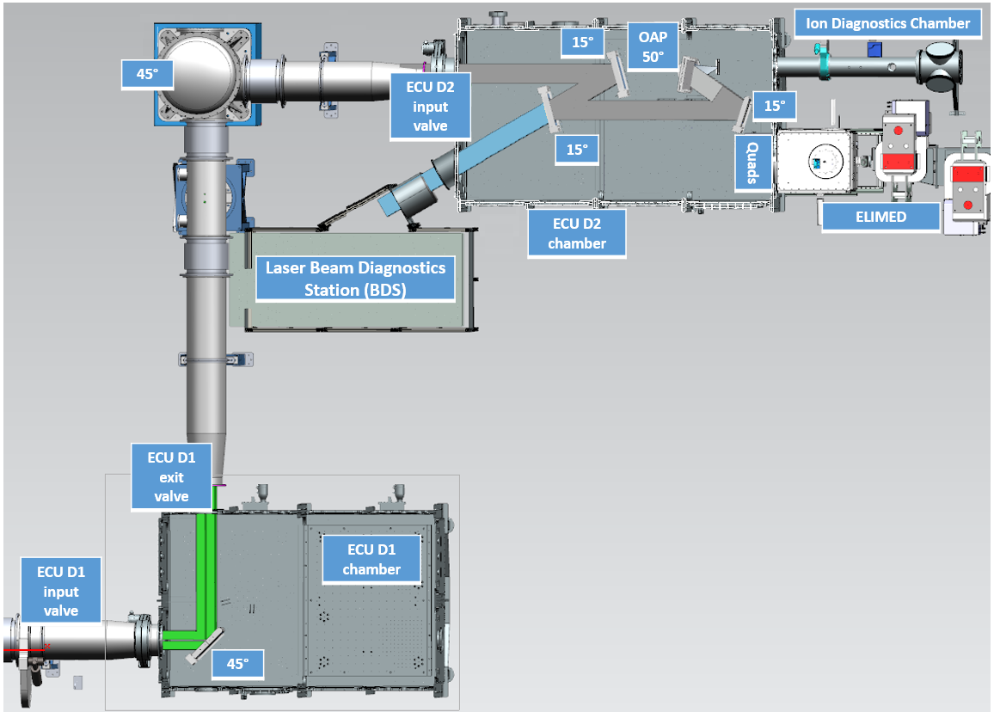
To reach the target at a 20° angle of incidence, the beam arriving from CH060 undergoes reflections from mirrors A, B, and C before reaching the 375 mm focal length off-axis parabolic mirror. Mirror B functions as a leaky optic, passing a minor fraction of the laser energy down to the Beam Diagnostics Station in air. This setup enables shot-by-shot, high-power characterization of the L3 near-field, far-field (for evaluating pointing stability), and nanosecond contrast. Additionally, the chamber panel positioned in the target-normal direction relative to the target's back surface features multiple flanges designated for ion diagnostic instrumentation.
Figure 1: Laser beam path layout within the experimental hall.
At ELIMAIA, the default target mounting system consists of a raster-type foil holder designed to hold roughly 700 targets distributed across eight individual sub-frames. The targets are prepared by sandwiching a 30 mm by 30 mm rectangular foil between two perforated plates. While this assembly method is ideal for foils that are 1 µm thick or greater, thinner or micro-structured targets require the user to supply them in a specialized holder. To support this custom hardware, the system's sub-frames can be modified or adjusted accordingly.
Available online ion diagnostics include time-of-flight diamond detectors, an MCP-based Thomson parabola ion spectrometer, a scintillator X-ray detector, and (for specific interaction geometry) an XUV spectrometer [2, 3]. In addition, 3-inch and 0.5-inch diameter pick-offs from the main laser beam have been successfully implemented to support specific needs of the user, such as optical probing or target pre-heating.
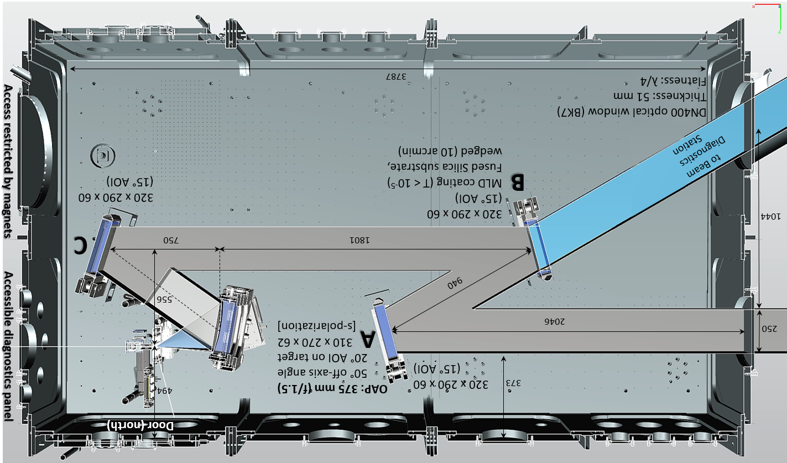
In its standard performance state, the ELIMAIA accelerator provides a typical target normal sheath acceleration (TNSA) spectrum from µm thick solid targets. It achieves a maximum proton cutoff energy of 40 MeV using 2 µm thick Cu targets and yields a total proton flux above 3 MeV of 10¹¹ sr⁻¹ [2, 3]. Ion beams with different properties can be generated in user experiments using different targets and experimental setups.
Figure 2: Laser beam path within the ECU-D2 interaction chamber.
Parts of the magnetic section for the transport and handling of laser-driven ion beams generated in the target chamber are shown in Fig. 3. ELIMED utilizes a system of permanent magnet quadrupoles to collect a controlled bandwidth of the ion beam's energy spectrum, injecting it into a four-dipole-based magnetic chicane for selection. The energy spread of the selected spectrum can be finely tuned by adjusting the aperture of the energy-selection slit used to cut off unwanted particles. The final section of ELIMED consists of additional quadrupoles and steerers to deliver the beam to a sample [4].
ELIMED currently features a proton output energy ranging from 20 to 25 MeV with a verified transmission efficiency of 4%. It provides a nominal output beam size of 0.1–10 mm, an energy spread of 10–15% (to be verified), a proton bunch duration of 10 ns, and delivers a dose of 30 mGy/shot at the entrance to the Bragg peak.
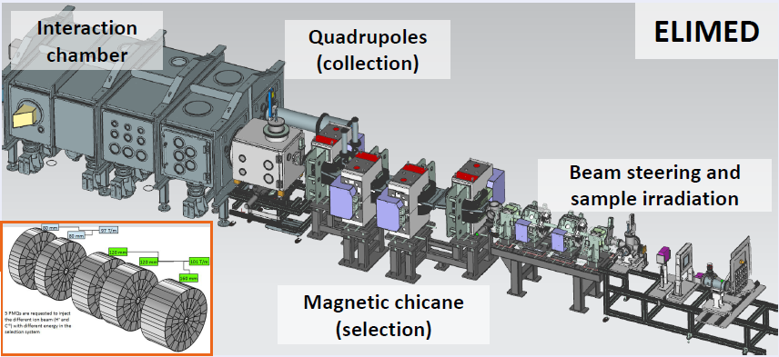
Since October 2023, when user operations started, up to the present date (June 2026), 20 experimental campaigns have taken place, with 10 utilizing ELIMAIA and 10 utilizing the full ELIMED beamline. Over these 164 days of high-power beamtime, the platform delivered more than 52,000 high-power shots, ranging from 300 to 19,000 shots per campaign, with capabilities allowing up to 1,000 shots on solid targets per day. These campaigns integrated unique user setups, including a 12-µm Kapton tape drive, a liquid water jet, and a cryogenic hydrogen jet.
Figure 3: Magnetic section of the beamline. The inset shows the permanent magnet quadrupoles used for collection of the laser-driven ion beam.
The beamline has successfully enabled multidisciplinary applications of laser-driven proton beams across cultural heritage and life sciences. These include proton-induced X-ray emission (PIXE) measurements of historical artifacts in collaboration with the City of Prague Museum, as well as the radiobiological irradiation of cell lines at ELIMED in collaboration with the Institute of Microbiology of the Czech Academy of Sciences [5].
Looking forward, upcoming upgrades will further expand the beamline's capabilities. Double plasma mirrors are being prepared in a dedicated optical setup inside a separate vacuum chamber, where initial testing successfully demonstrated the production of ions from 25-nm-thick targets. Additionally, continuously replenished targets—including both cylindrical and planar water jets—are currently being tested to support high-repetition-rate, debris-free operations.
References
- D. Margarone, et al. ELIMAIA: A Laser-Driven Ion Accelerator for Multidisciplinary Applications. Quantum Beam Science, 2(2), 8 (2018)
- F. Schillaci, et al. The ELIMAIA Laser–Plasma Ion Accelerator: Technological Commissioning and Perspectives. Quantum Beam Science, 6(4), 30 (2022).
- L. Giuffrida, et al. The ELIMAIA laser-plasma Ion Accelerator: a platform for open-access user experiments (submitted to PRAB).
- G. A. P. Cirrone, et al. ELIMED-ELIMAIA: The First Open User Irradiation Beamline for Laser-Plasma-Accelerated Ion Beams. Frontiers in Physics, 8, 564907 (2020)
- P. Bláha, et al. ELIMAIA-ELIMED: A new user platform for radiobiological research utilizing laser-driven protons. Frontiers in Physics, 13, 1567622 (2025)

