Improving laser-driven proton beam divergence and uniformity by using self-generated EM multipoles in channel-shaped targets
M. Greplova Zakova¹, J. Psikal², F. Schillaci¹, F. Grepl¹, D. Margarone¹, L. Giuffrida¹
1 The Extreme Light Infrastructure ERIC, ELI Beamlines Facility, Dolní Břežany, Czechia
2 Faculty of Nuclear Sciences and Physical Engineering, CTU in Prague, Prague, Czechia
Improving the angular properties of laser-accelerated ion beams is essential for advancing the applicability of laser-driven ion sources. This work provides a brief summary of key findings, together with additional comments on a comprehensive 2D and 3D PIC study of advanced plastic target designs aimed at reducing proton beam divergence (up to 80% in favorable energy interval and plane) while preserving high energies and particle yields, as reported in [1]. The parametric study [1], [2] compares flat and curved foils with a range of rear-side channel geometries and identifies a flat foil with straight cylindrical channel as the most effective configuration. The channel structure generates a long-lasting transverse focusing electric field (in contrast to a flat foil) and, importantly, induces a distinctive electromagnetic field topology within the guiding cylinder. These self-generated fields include a magnetic quadrupole with a pronounced octupole component – an effect analogous to conventional multipole magnets. The resulting field configuration substantially reduces proton beam divergence and improves spatial uniformity across a broad energy interval. Moreover, a realistic scenario was also modelled by including a prepulse-generated preplasma at the front side of the optimal channel target design, enabling direct comparison between ideal and experimental laser conditions (Comment 1). Additional investigations address several mechanisms that influence ion beam characteristics, including the role of linear polarization direction (Comment 2) and EM field inversions (Comment 3).
Summary of Previous Findings: Formation of Magnetic Multipoles
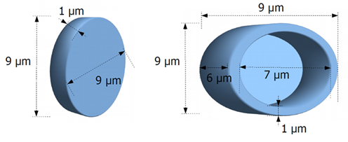
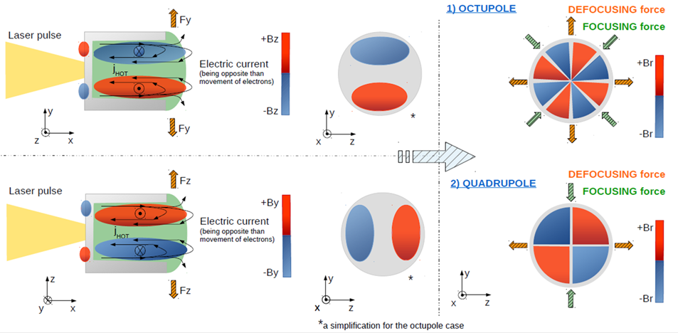
The magnetic field resulting from laser pulse interaction (L3 HAPLS laser parameters [6], i.e. dimensionless laser amplitude a₀=48, laser intensity 5×10²¹ W/cm², wavelength 800nm, pulse duration (FWHM) 30fs, beam width (FWHM) 3µm, normal incidence) with a plastic cylinder target (Fig. 1) resembles a multipole magnet, specifically a quadrupole with a strong octupole component. This multipole B-field originates from the collective motion of laser-accelerated electrons, particularly their organized transport along the channel walls (confined by the geometry and forming structured current loops). These currents generate transverse magnetic field components (primarily $B_{y}$ and $B_{z}$), which combine to produce a radial magnetic field, see Fig. 2. Unlike in flat targets – where electron motion is disorganized and fields rapidly decay – this structured electron motion leads to a well-defined magnetic configuration within the channel. The quadrupole component focuses particles in one transverse plane while defocusing in the perpendicular one, thereby introducing anisotropic beam shaping (see [1], [2] for more details). The octupole component, which naturally appears as a higher-order harmonic due to imperfections and asymmetries, contributes to improving beam uniformity by smoothing spatial variations. This combination explains both the observed reduction in divergence (up to 80%) and the enhanced homogeneity of the particle beam (up to 30%). To compare, the magnetic field integral for the channel target starts at 0.217 T·m, peaks at 0.368 T·m, then decreases to 0.098 T·m by the end; ELIMAIA quadrupoles have 10 T/m over 70 mm → 0.084 T·m, PMQs have 100 T/m over 36 mm → 0.291 T·m, [3], [4]. This means that the channel-target field integral exceeds that of the ELIMAIA quadrupoles throughout the acceleration process.
Fig. 1: Plastic target designs chosen according to 2D comparative study for 3D PIC simulation; study published in [1,2].
Fig. 2: Schematic sketch of the establishment of magnetic field components driven by electron motion, i.e., by the formation of current loops, and of the magnetic multipoles creation in all planes of Cartesian coordinate system. Both magnetic octupole and quadrupole were observed inside the channel, depending on the time and the position along the channel length.

Summary of Previous Findings: Defocusing and Focusing Electric Fields
The focusing effect in channel targets originates from transverse electric fields (E_{y}, E_{z}). In the channel case, these fields maintain a focusing orientation, whereas in the flat foil they reverse after a few tens of fs, see Fig. 4 in article [1]. In the flat foil case, the fields switch to defocusing, pushing protons away from the laser axis and increasing beam divergence.
Comment 1: Non-ideal laser contrast: Preplasma impact
The impact of preplasma, generated by a realistic laser prepulse (I_{p} = 10¹¹ W/cm², duration 0.5 ns), was studied using additional 2D PIC simulations with input from MHD modeling. The results show that preplasma leads to a temporary increase in laser intensity due to self-focusing, causing a slight rise in maximum proton energy (due to the higher accelerating E_{x} field resulting from a 55% increase in electron temperature) and a flatter energy spectrum due to enhanced front-side acceleration. At the same time, a modest increase in divergence is observed due to the larger angular spread of hot electrons generated in the preplasma (though at relatively low intensity to be effective [5]). No other accelerating mechanisms have been observed. Overall, the channel target design appears reasonably robust against weak prepulses.
Figure 3: Comparative preplasma study: Energy spectra of protons (solid lines) and carbon ions (dashed lines) taken at the end of 2D PIC simulations, i.e., at 270 fs after the start of laser-target interaction.
Comment 2: Impact of laser polarization direction on beam divergence and beam shape
The direction of laser polarization strongly influences proton beam shape and divergence through its effect on electron dynamics and the resulting EM fields inside and behind the target. Previous studies of RT (relativistically transparent) targets showed that linearly polarized pulses generate a diffraction structure, producing a double-lobed proton beam perpendicular to the polarization direction [7], [8]. This is caused by electron expulsion from high-field regions along the polarization axis, which modulates the electrostatic field and imprints onto the proton beam [8]. In simulations presented here, however, the target does not fully reach RT, although a partially transmitted pulse still interacts with the rear side. Consequently, the expected diffraction pattern is absent, and the proton beam elongates along the polarization direction instead. This behavior is linked to the transmitted pulse propagating in a TE₀₁ mode, which modifies the transverse electric fields [2]. Polarization affects proton divergence moderately (~10%), depending on observation plane and proton energy [2]. Lower-energy protons are more sensitive to these fields, while higher-energy protons remain less affected. Notably, the divergence tends to be slightly reduced in the plane parallel to polarization, and rotating polarization by 90° swaps the divergence properties between transverse planes. Although polarization modifies the bulk proton distribution, the central narrow filament remains unchanged. Overall, beam divergence and shape result from the interplay of transverse E-fields, electron confinement, and B-field structures, with polarization mainly altering electric field strength and orientation (see Fig. 4).
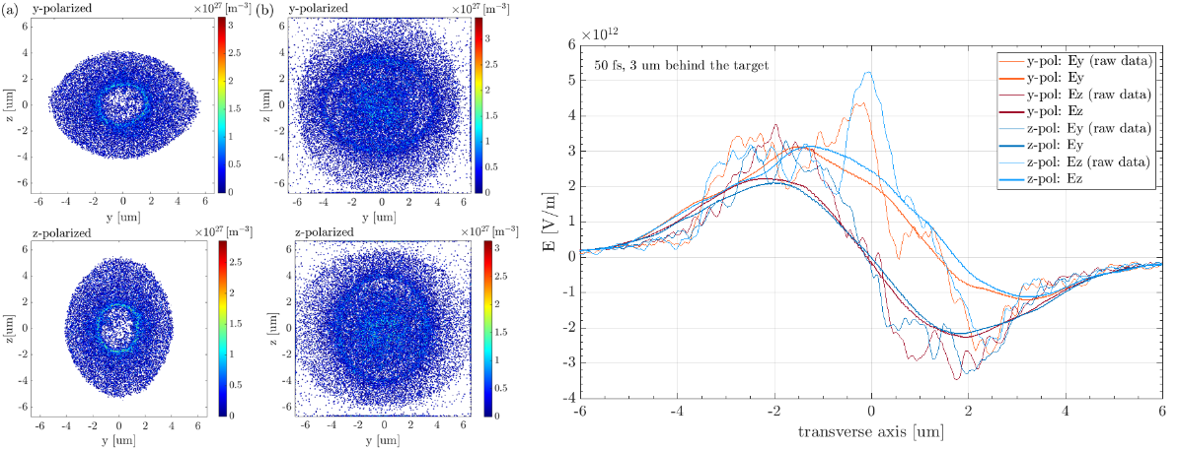
Fig. 4: Left: Density plots comparison of the proton beam cross sections in the case of the reference flat target interacting with y−linearly or with z−linearly polarized laser pulse. The beam cross sections are shown at 6.5 μm behind the target rear surface at (a) 180 fs or at (b) 270 fs after the start of laser-target interaction. Right: Comparison of 1D profiles of transverse focusing electric field components plotted along corresponding axes, i.e., E_{y}−y and E_{z}−z, for linearly y− and z−polarized laser pulses.
Comment 3: The inversion in focusing components of electric and magnetic fields
Field inversion, known in plasma physics, arises from atypical electron motion or irregular
magnetic structures. In the presented simulations, a small inversion appears near the laser axis in both electric and magnetic fields due to ponderomotive electron expulsion and the formation of opposing current loops.
The inverted field propagates along the laser axis toward the target rear and decays within ~100 fs, following electron dynamics. It leads to proton beam defocusing via the electric field and alters magnetic focusing properties. The effect is stronger in channel targets than in flat foils, where it is weaker and short-lived due to reduced electron confinement.
Fig. 5: Field inversion in EM fields of the channel target: (a) E_{y} and E_{z} affecting focusing of ions at 80 fs and x = 0 μm, the field inversion is highlighted by red regions; transverse magnetic field B_{z} showing gradual movement and continuous disappearance of the magnetic field inversion (marked in black oval in (b)) at (b) 90 fs, (c) 170 fs and 240 fs.
Conclusions
An important advantage of directly reducing beam divergence through target shaping is the improved matching of the beam to the entrance aperture of beamline transport systems. For example, in the ELIMED section of the ELIMAIA beamline [3], [4], about 36% of protons (>10 MeV) from a flat foil would be clipped when entering the transport system, compared to only 9% in the case of the channel target. These findings demonstrate that structured channel targets can act as passive beam-conditioning elements, offering a promising route toward controllable and application-ready laser-driven proton beams.
References
- M Greplova Zakova et al 2021 Plasma Phys. Control. Fusion 63 085005
- Greplová Žáková, M. (2021). Laser Ion Acceleration: Theory and Simulation [PhD dissertation, Czech Technical University in Prague: Faculty of Nuclear Sciences and Physical Engineering]. https://dspace.cvut.cz/entities/publication/a5717c7b-c438-4a01-9a9f-5bf6987e8c9e
- Schillaci, F., et al. "Design of the ELIMAIA ion collection system." Journal of Instrumentation 10.12 (2015): T12001-T12001.
- Margarone, Daniele, et al. "ELIMAIA: A laser-driven ion accelerator for multidisciplinary applications." Quantum Beam Science 2.2 (2018): 8.
- Ovchinnikov, V. M., et al. "Effects of Preplasma Scale Length and Laser Intensity on the Divergence of Laser-Generated Hot Electrons." Physical Review Letters 110.6 (2013): 065007.
- Sistrunk, E., et al. "All diode-pumped, high-repetition-rate advanced petawatt laser system (HAPLS)." CLEO: Science and Innovations. Optica Publishing Group, 2017.
- Gonzalez-Izquierdo, Bruno, et al. "Towards optical polarization control of laser-driven proton acceleration in foils undergoing relativistic transparency." Nature communications 7.1 (2016): 12891.
- Gonzalez-Izquierdo, Bruno, et al. "Optically controlled dense current structures driven by relativistic plasma aperture-induced diffraction." Nature Physics 12.5 (2016): 505-512.

