Simultaneous Nitrogen Fixation and CO₂ Conversion via Magnetic Field Stabilized Glow Discharge (MSGD)
Yuexi Liu¹, Yiqian Li¹, Licheng Yang¹, Lanlan Nie¹, XinPei Lu¹, Dawei Liu¹
1 State Key Laboratory of Advanced Electromagnetic Engineering and Technology, School of Electrical and Electronic Engineering, Huazhong University of Science and Technology, Wuhan, HuBei, China
- Introduction
The sustainable conversion of abundant small molecules such as N₂ and CO₂ is of great importance for future chemical and energy systems. Nitrogen fixation (NF) is traditionally dominated by the Haber–Bosch process, which requires high temperature and pressure and relies heavily on fossil/fuel/based hydrogen. Meanwhile, CO₂ conversion into value/added chemicals such as CO provides a potential route for carbon recycling.
Non/equilibrium plasma has attracted increasing attention because energetic electrons can activate stable molecules under ambient or near/ambient conditions. In plasma systems, N₂ and CO₂ can be excited, dissociated, and converted through electron/impact reactions, vibrational excitation, and thermal or radical/assisted pathways. However, atmospheric/pressure plasma conversion still faces challenges including discharge instability, limited energy efficiency, and competition between different reaction channels.
In this work, a MSGD device is employed for simultaneous NF and CO₂ conversion. The magnetic field helps stabilize the glow discharge at atmospheric pressure, providing a controllable plasma environment for gas/phase chemical conversion, as illustrated in Fig. 1. Two gas systems, N₂/CO₂ and air/CO₂, are investigated to compare the effects of gas composition on NO_{x} and CO production. The performance is evaluated in terms of product concentration, energy cost, and energy efficiency. Optical emission spectroscopy is further used to support the analysis of plasma parameters and reaction mechanisms.
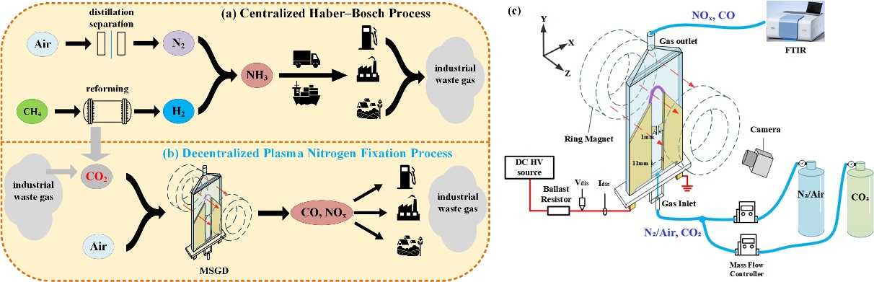
Fig. 1. Schematic of the experiment setup. (a) centralized Haber/Bosch process, (b) decentralized plasma NF and CO₂ reutilization; (c) experiment setup of MSGD device for simultaneous NF and CO₂ conversion by using N₂/air and CO₂ as working gas.
- Experiment Setup
Fig. 1(c) shows the experimental setup for NF and CO₂ conversion using N₂/air–CO₂ gas mixtures. The MSGD device consists of two parallel brass electrodes separated by 11 mm, with quartz glass plates on both sides forming the gas channel. Each electrode has a 1 mm thick tip, and the minimum gap between the two tips is 1 mm to facilitate breakdown. A pair of annular permanent magnets is placed on both sides of the device along the z-axis, generating a magnetic field perpendicular to the electrode plane. The magnetic field strength in the central plasma region is about 100 mT.
The high/voltage electrode is powered by a DC power supply through a 50 kΩ current/limiting resistor, while the other electrode is grounded. The discharge voltage and current are measured using a high/voltage probe and a current probe, respectively. The main gaseous products, including CO, NO, and NO₂, are analysed by FTIR after passing through a PTFE tube. The FTIR signals are calibrated using standard gas mixtures to obtain absolute product concentrations. Plasma images are recorded using a digital camera, and optical emission spectra in the range of 200-800 nm are measured using a spectrometer.
- Results and Discussions
3.1 Photographs, Electrical Characteristics, and Emission Spectrum of the MSGD plasma
Fig. 2 shows photographs of the plasma generated from an air and CO₂ mixture (air/CO₂=7/4), along with waveforms of the discharge voltage and current. As shown in Fig. 2(a), under the combined effect of the Lorentz force and the gas flow, a stable U-shaped plasma channel is formed. According to Li et al.[1], this discharge mode is classified as glow discharge. As shown in Fig. 2(b), the discharge voltage and current are 2.42 kV and 51.4 mA, respectively. Because the discharge remains stable, the voltage and current are almost constant over time, resulting in a plasma power of approximately 124.4 W.
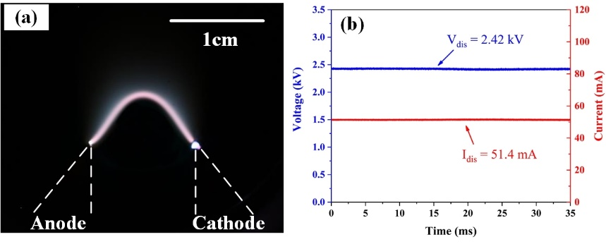
Fig. 2. (a) Photograph of the plasma and (b) the discharge voltage and current waveforms.
The emission spectrum of the plasma in the center of the U/shaped plasma channel was measured in the 200-800 nm range using air and CO₂ mixture (air/CO₂=7:4) as working gas, as shown in Fig. 3. The spectrum clearly reveals the NO/γ lines and the CO(d-a) and CO(B-A) lines, indicating the presence of NO and CO in the plasma. Additionally, the emission spectrum also includes lines from species that play significant roles in NF and CO₂ conversion, such as N₂(C), N₂(B), N₂(A), O atoms, OH, and CO₂(B-X).
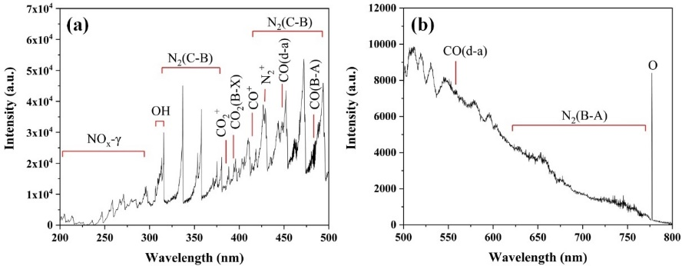
Fig. 3. Optical emission spectrum of the plasma. (a) 200-500 nm; (b) 500-800 nm.
3.2. Gas composition on NF and CO₂ conversion efficiency
To investigate the effects of different gas compositions on NF and CO₂ conversion in magnetic field stabilized glow plasma, we conducted experiments using varying ratios of CO₂ with N₂ and air. The gas flow rate was maintained at 5.5 L/min, and the plasma power was kept at approximately 120 W.
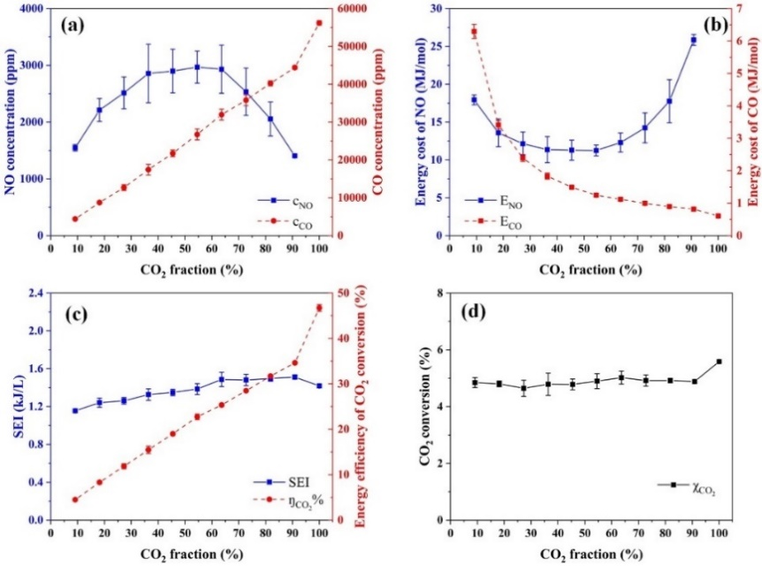
Fig. 4. The results of the N₂ mixed with different CO₂ ratio: (a) concentrations of NO and CO; (b) energy cost for CO and NO; (c) specific energy input (SEI) and energy efficiency of CO₂ conversion; (d) absolute conversion rate of CO₂.
Fig. 4(a) shows the concentrations of CO and NO_{x} at various CO₂ volume fractions using the N₂/CO₂ mixture discharge. The CO concentration increases with the increase of CO₂ volume fraction, reaching a maximum of 56,198 ppm at a CO₂ volume fraction of 100%. In the mixed N₂/CO₂ discharge, the concentration of NO₂ in the products is nearly at the detection limit and thus is negligible. The concentration of NO first increases and then decreases as the CO₂ volume fraction rises, peaking at 2,968 ppm when the CO₂ volume fraction is 54.5%. Fig. 4(b) shows the energy cost for NF and CO₂ decomposition into CO. Following the concentration trend, NF energy cost is lowest at 11.24 MJ/mol when the CO₂ volume fraction is 54.5%. For CO₂ decomposition, the energy cost reaches a minimum of 0.61 MJ/mol at a CO₂ volume fraction of 100%. As shown in Fig. 4(c), The energy efficiency of CO₂ decomposition also gradually rises with increasing CO₂ volume fraction, reaching a maximum of 46.7%. Finally, Fig. 4(d) demonstrates that the absolute CO₂ conversion rate remains almost constant at around 5%, regardless of CO₂ volume fraction.
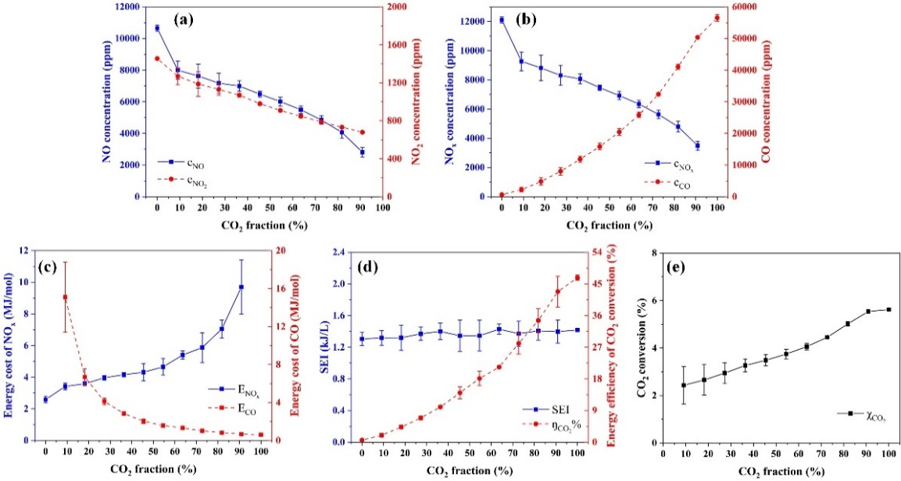
Fig. 5. Results of the air and CO₂ mixture discharge at various CO₂ volume fractions: (a) concentrations of NO and NO₂; (b) concentrations of NO_{x} and CO; (c) energy cost for CO and NO_{x}; (d) SEI and energy efficiency of CO₂ conversion; (e) absolute conversion rate of CO₂.
From Fig. 5(a) and Fig. (b), the concentration of NO_{x} decreases as the CO₂ volume fraction increases, peaking at 0% CO₂ with a concentration of 12,103 ppm, approximately 4 times higher than the maximum observed in the N₂/CO₂ mixture. Notably, the concentration of NO₂ is quite low in the N₂/CO₂ mixture discharge, whereas a higher concentration of NO₂ is detected in the air/CO₂ mixture discharge, as shown in Fig. 5(a). Fig. 5(c) illustrates the energy cost for the air/CO₂ mixture discharge. Following the same trend as the concentrations, the energy cost for NF is lowest at 0% CO₂, at 2.59 MJ/mol, representing a 77.0% reduction compared to best value of the N₂/CO₂ mixture. The energy cost for CO₂ decomposition is minimized at 100% CO₂, at 0.61 MJ/mol. According to Fig. 5(d), the energy efficiency of CO₂ decomposition gradually increases with the CO₂ volume fraction, reaching a maximum of 46.7% in pure CO₂. Unlike the N₂/CO₂ mixture discharge, the absolute conversion rate of CO₂ increases with the CO₂ volume fraction for the air/CO₂ mixture discharge, rising from 2.4% to 5.6%.
3.3 Analysis of Plasma Gas Temperature and Reaction Pathways of Gas/Phase Products
The discharge channel remains stable because the aerodynamic drag force and the magnetic/field/induced Lorentz force have comparable magnitudes but opposite directions. The average electric field is estimated from the discharge voltage and plasma channel length measured from discharge images, with the cathode drop voltage corrected using typical atmospheric/pressure values of 208 V for N₂, 370 V for air, and 460 V for CO₂. As shown in Figure 6(a), the average electric field is almost independent of gas composition and remains approximately 1.36 kV/cm.
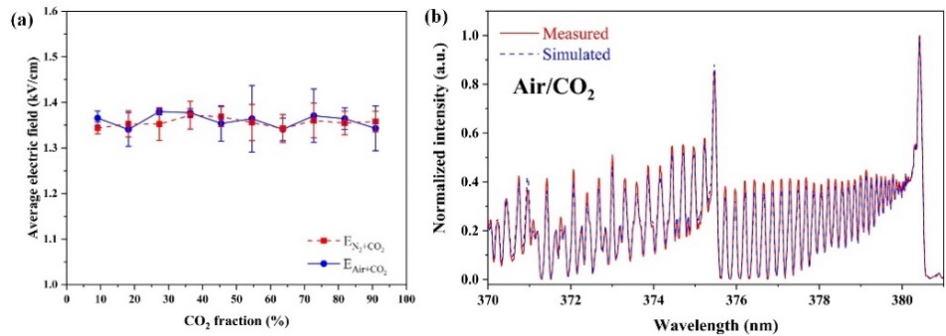
Fig. 6. (a) Average electric field of the plasma for different CO₂ fraction; (b) measured and simulated spectra at N₂(C³Π_{u} − B³Π_{g}) (Δv = −2) transition.
For air/CO₂ discharge, spectral fitting of the N₂(C–B) band gives a gas temperature of 2680 ± 80 K. Combined with the average electric field, the reduced electric field is estimated to be approximately 49.6 Td. Under this condition, more than 90% of the electron energy is transferred to vibrational excitation of N₂ and CO₂. Therefore, NO is primarily generated through the vibrationally excited Zeldovich mechanism, as shown in reactions (1) and (2). At this reduced field strength, CO is produced by the dissociation of vibrationally excited CO₂, as represented by reactions (3) and (4).
${e+N}_{2}→e+N_{2}\left(v\right)$ (1)
$N_{2}\left(v\right)+O→NO+N$ (2)
$e+{CO}_{2}→e+{CO}_{2}\left(v\right)$ (3)
${CO}_{2}\left(v\right)→O+CO$ (4)
- Conclusion
A MSGD device was applied to simultaneous NF and CO₂ conversion at atmospheric pressure. CO production increased with CO₂ fraction, reaching 56,198 ppm in pure CO₂, with a minimum CO₂ conversion energy cost of 0.61 MJ/mol and a maximum energy efficiency of 46.7%. For NF, the lowest energy cost was 11.24 MJ/mol in N₂/CO₂ discharge and 2.59 MJ/mol in air discharge. Mechanism analysis indicates that CO is mainly produced through vibrationally assisted CO₂ dissociation, while NO is primarily formed through the Zeldovich mechanism.
References
- Li Z, Nie L, Liu D and Lu X 2022 An atmospheric pressure glow discharge in air stabilized by a magnetic field and its application on nitrogen fixation Plasma Process. Polym. 19 2200071

