Surface Modification of Titanium by Nanosecond Pulsed Low-Pressure Nitrogen-Hydrogen Plasma for Enhanced Antibacterial and Osteogenic Performance
Yiqian Li*, Yuexi Liu, Xinlei Zhang, Lanlan Nie, and Xinpei Lu
School of Electrical and Electronic Engineering, Huazhong University of Science and Technology, Wuhan, China
Abstract
Titanium is widely used for dental implants. However, bacterial adhesion and insufficient early cell attachment remain important challenges. Here, smooth titanium and sandblasted acid-etched (SLA) titanium were modified by nanosecond-pulsed low-pressure N₂+H₂ plasma. The treatment was performed at 200 Pa using a 95% N₂ and 5% H₂ gas mixture. Plasma treatment did not visibly change the surface morphology, but strongly improved surface hydrophilicity by removing carbon contaminants and introducing nitrogen-containing functional groups. The modified surfaces reduced Streptococcus mutans adhesion by more than four orders of magnitude and improved MC3T3-E1 pre-osteoblastic cell adhesion without detectable cytotoxicity. These results suggest that nanosecond-pulsed N₂+H₂ plasma is an effective and low-cost strategy for producing titanium implant surfaces with combined antibacterial and osteogenic potential.
1. Introduction
Titanium is widely used for dental implants due to its mechanical stability, corrosion resistance, and biocompatibility. However, implant success largely depends on surface-mediated biological responses, including protein adsorption, osteoblast attachment, and antibacterial performance. Insufficient control of bacterial adhesion and biofilm formation may lead to peri-implant infection and implant failure.
Therefore, surface modification is crucial for improving titanium implant performance. Although commercial SLA titanium enhances osseointegration through increased roughness, it involves more complex and costly processing. Among various surface modification techniques, plasma treatment is an emerging and highly promising technology. Plasma, a collection of charged and neutral particles, can increase the surface energy of materials. Its modification effect on implants is typically achieved by removing adsorbed organic pollutants and introducing specific functional groups onto the surface [1-2].
.
2. Experimental methods
Commercially pure smooth titanium discs and SLA titanium discs were used as substrates. Before plasma treatment, all samples were ultrasonically cleaned in ethanol and deionized water and then dried at room temperature.
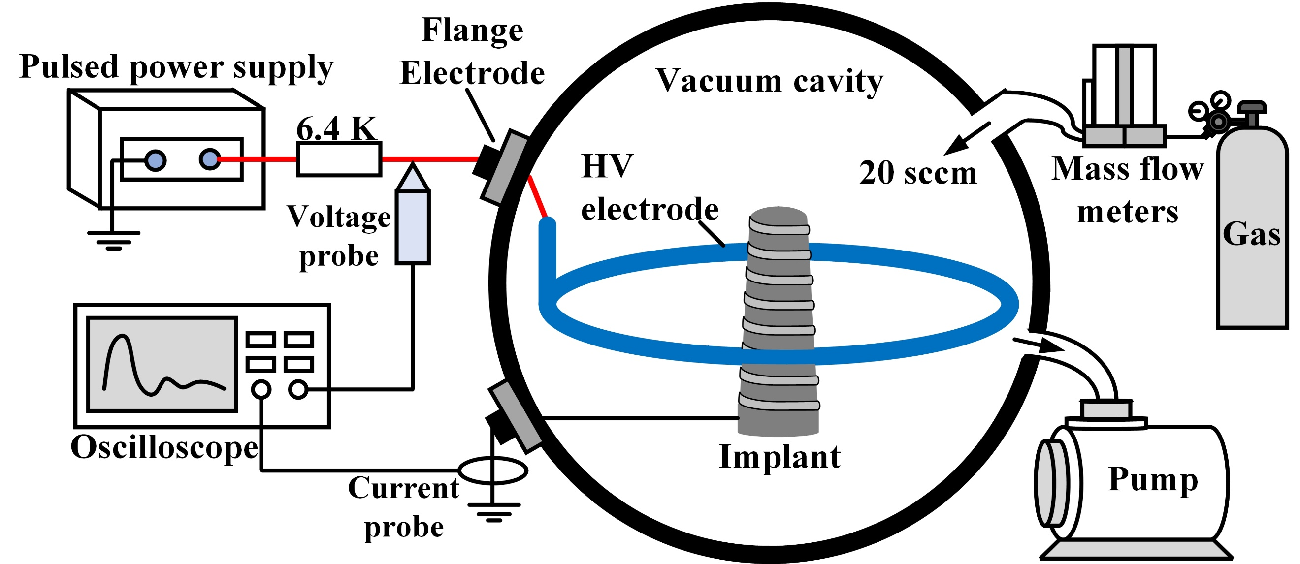
The plasma treatment was carried out in a low-pressure chamber driven by a nanosecond-pulsed power supply. A ring-shaped high-voltage electrode was used to generate a relatively uniform plasma around the sample. The treatment pressure was maintained at 200 Pa, and the working gas was 95% N₂ and 5% H₂.
Figure 1: Plasma treatment system
Surface wettability was evaluated by water contact angle measurement. A 5 μL deionized water droplet was placed on the titanium surface, and the contact angle was measured from the droplet image. Surface morphology was observed by scanning electron microscopy. Surface chemical composition was analyzed by X-ray photoelectron spectroscopy.
The antibacterial activity was evaluated using Streptococcus mutans, a bacterium related to dental plaque formation and peri-implant infection. After incubation on titanium surfaces, adherent bacteria were detached and quantified by colony counting. The biological compatibility of the modified surfaces was evaluated using MC3T3-E1 mouse pre-osteoblastic cells. Cell adhesion was examined by DAPI staining after short-term culture on the sample surfaces. Cytotoxicity was evaluated by CCK-8 assay.
3. Results and discussion
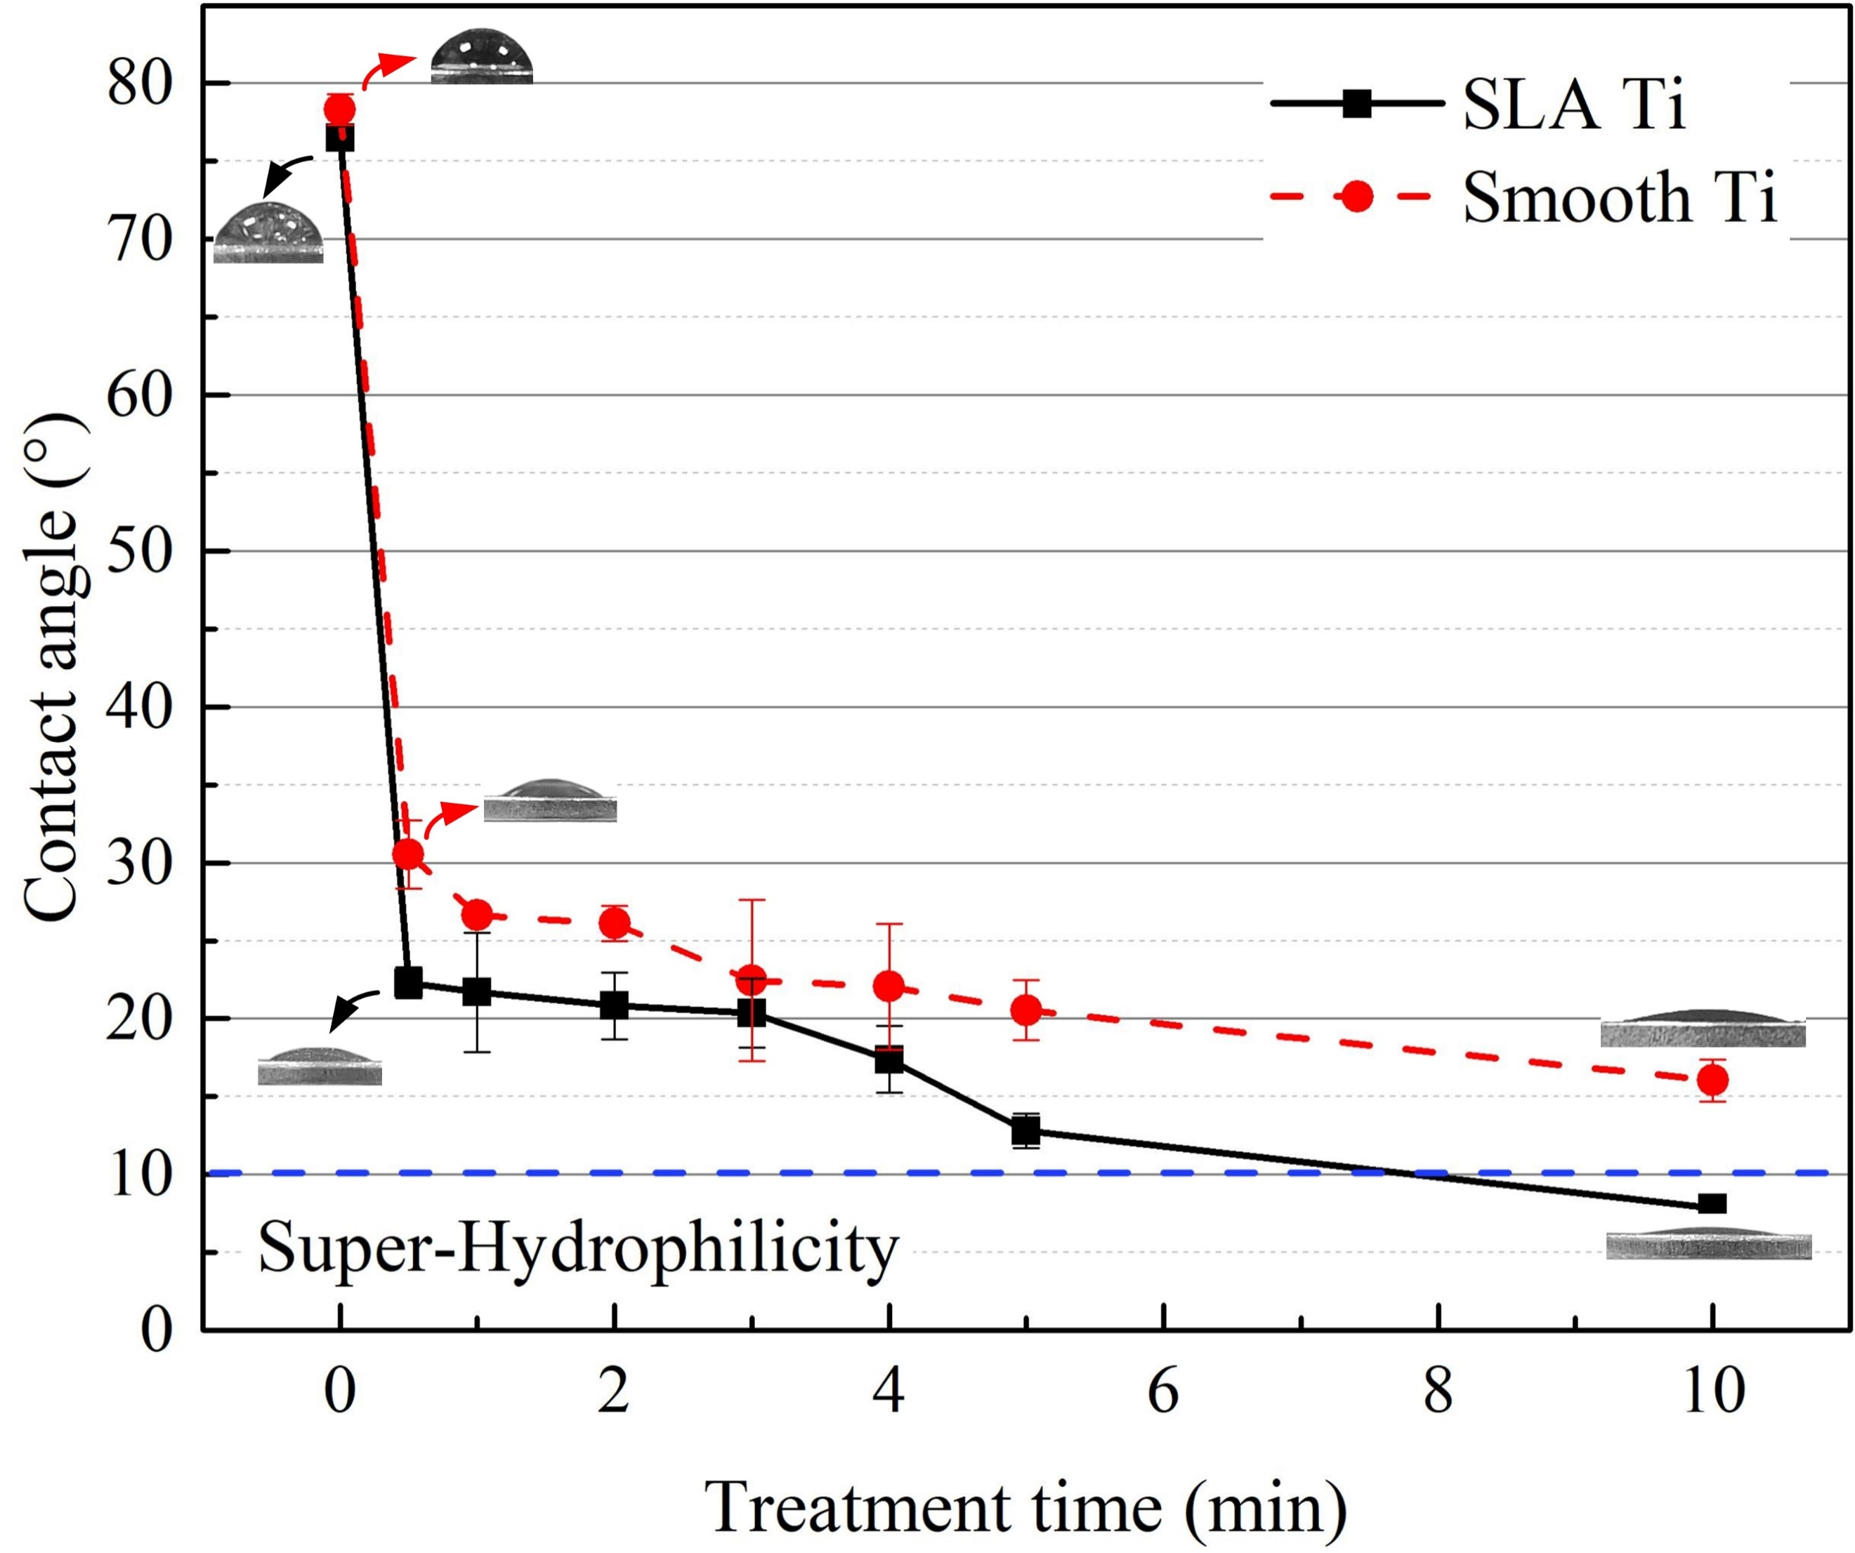
After plasma treatment, both SLA titanium and smooth titanium showed a marked improvement in hydrophilicity. The untreated SLA titanium surface had a water contact angle of 76.5°, while untreated smooth titanium showed a contact angle of 78.3°. After 10 min treatment with N₂+H₂ plasma, the contact angle decreased to 7.9° for SLA titanium and 16.0° for smooth titanium. This result indicates that the plasma treatment effectively transformed both surfaces from hydrophobic to highly hydrophilic.
Figure 2: Influence of plasma treatment time on the contact angle of titanium discs (Pressure: 200 Pa, Working gas: 95% N₂+ 5% H₂).
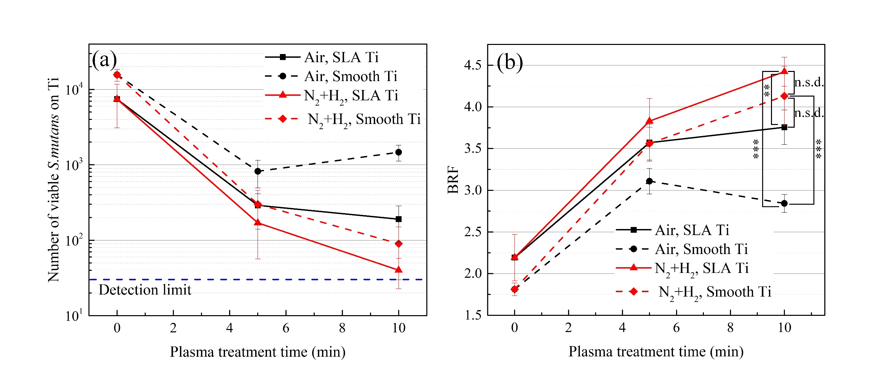
The plasma-modified surfaces also showed strong antibacterial activity against S. mutans. After N₂+H₂ plasma treatment, bacterial adhesion was reduced by more than four orders of magnitude. This antibacterial effect is closely related to the modified surface chemistry. Increased hydrophilicity can reduce hydrophobic bacterial attachment, while charged nitrogen-containing groups may interact with bacterial membranes and further suppress bacterial adhesion or survival.
Figure 3: Antibacterial properties of plasma-modified titanium discs (Pressure: 200 Pa). (a) Bacterial attachment on each Ti surface. (b) Quantitative assessment of antibacterial performance by the BRF.
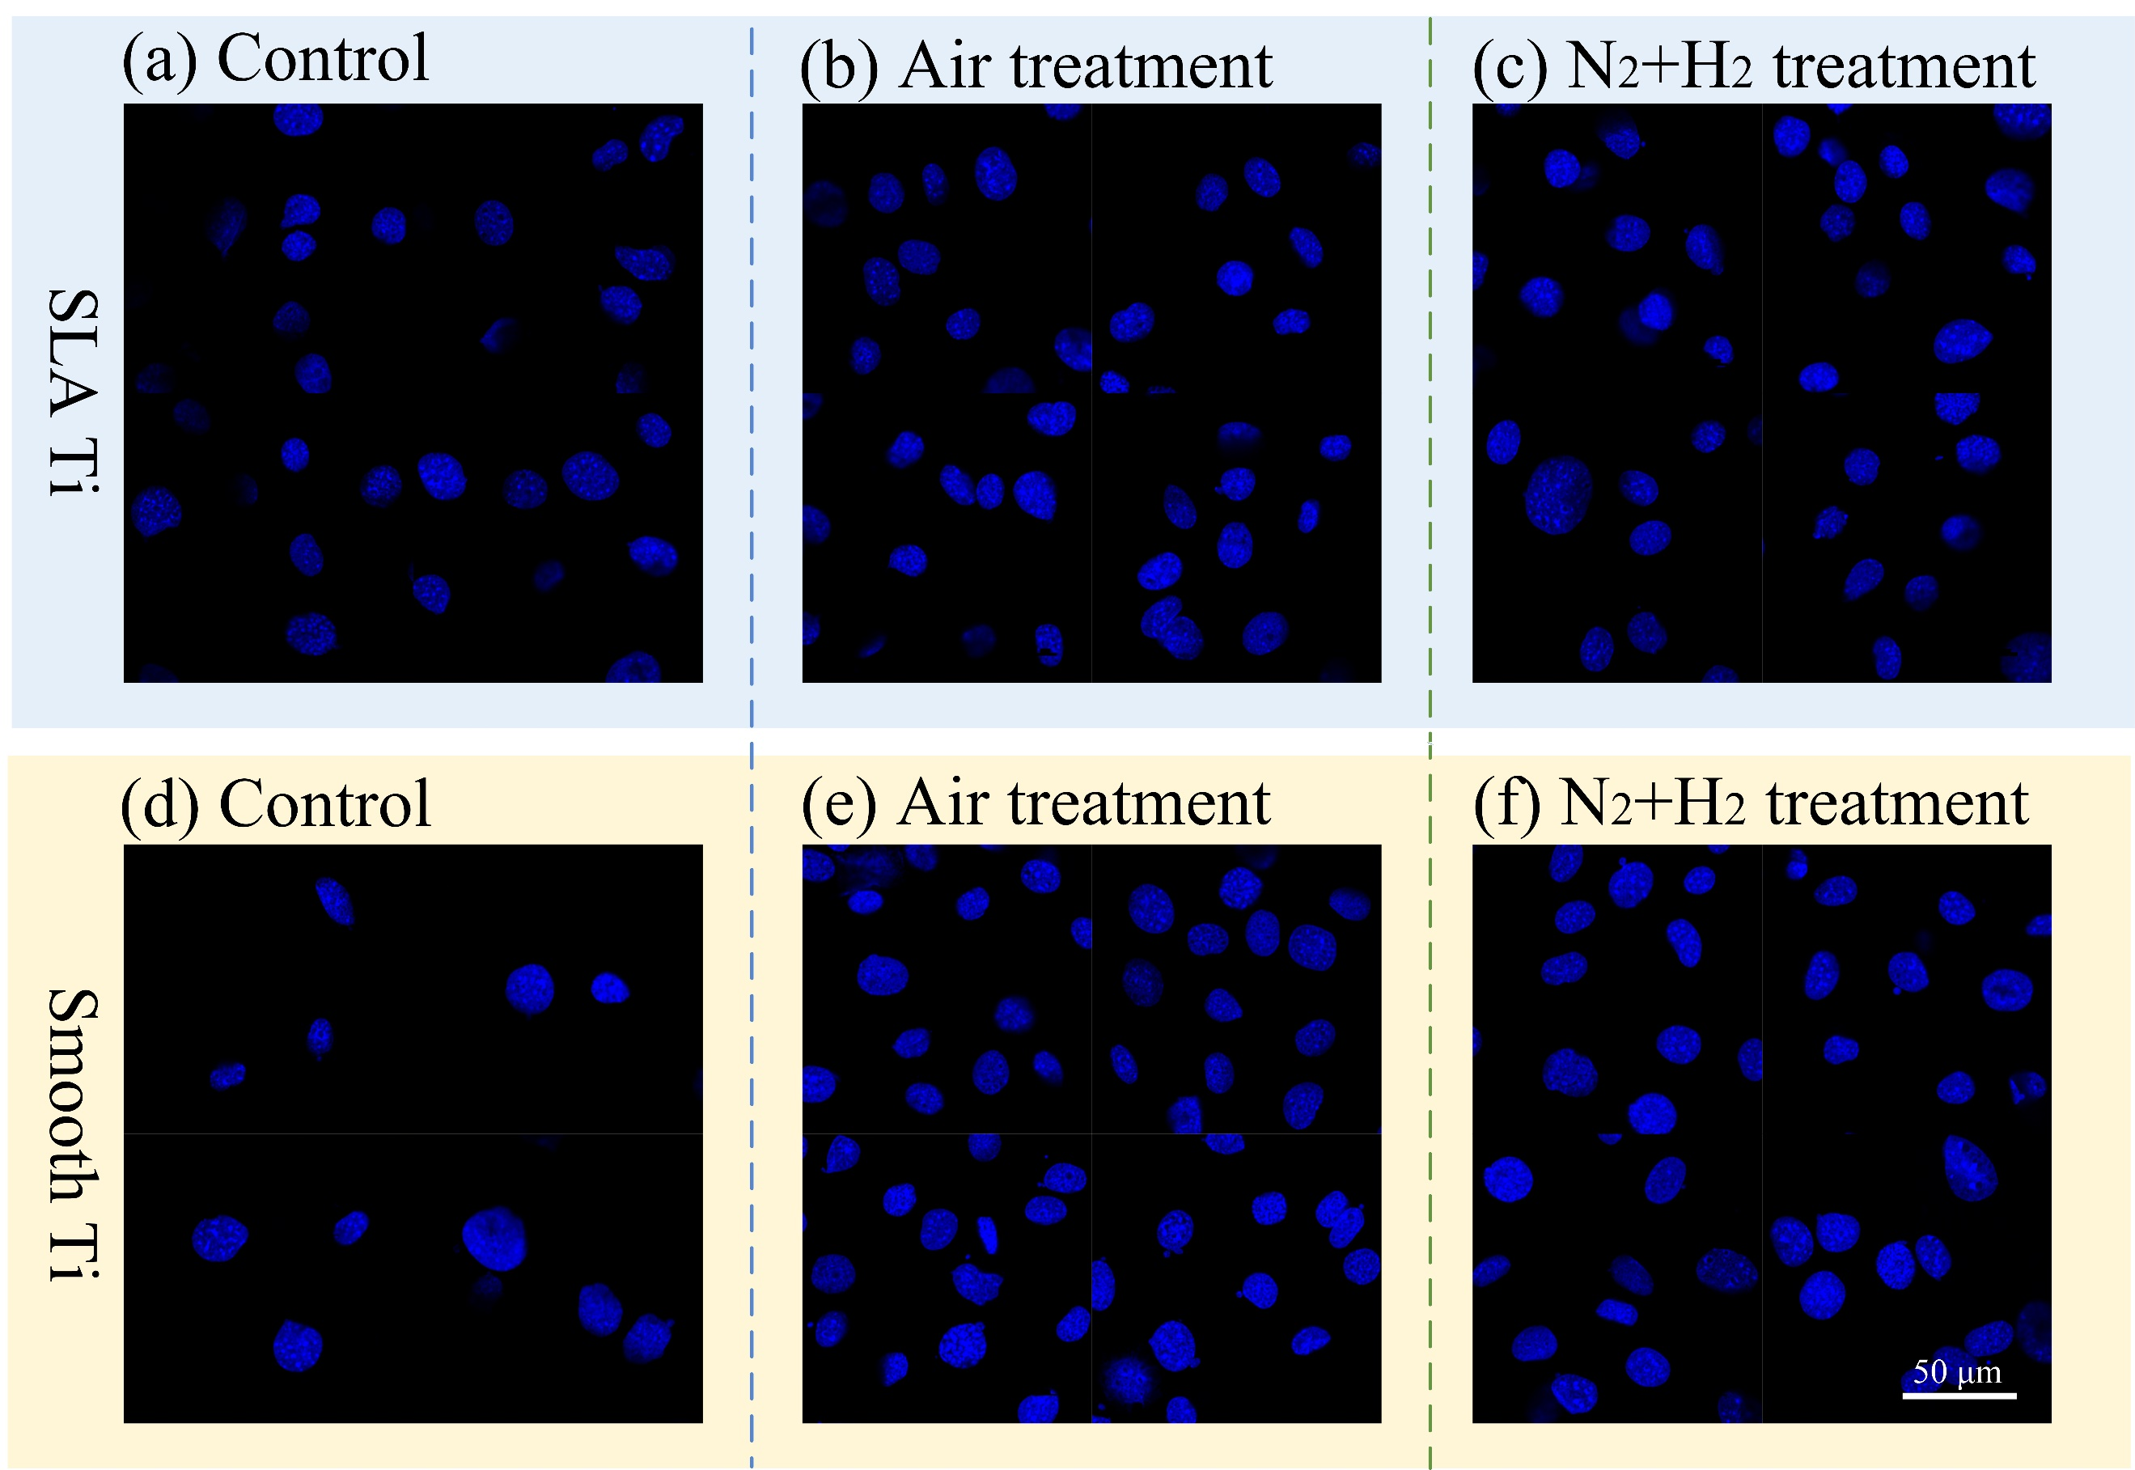
In addition to antibacterial activity, the modified surfaces promoted osteoblast-related cell adhesion. MC3T3-E1 pre-osteoblastic cell adhesion increased markedly after plasma treatment, reaching approximately 70% on the treated surfaces. This improvement is important because early osteoblast adhesion is one of the first steps toward osseointegration. The enhanced adhesion can be attributed to the increased hydrophilicity and the presence of polar functional groups, which may improve protein adsorption and provide a more favorable interface for cell attachment.
Figure 4: Fluorescence microscopy images of cell adhesion on plasma-modified titanium disc surfaces (DAPI staining) (Pressure: 200 Pa, Treatment time: 10 min).
The CCK-8 assay showed that the plasma-modified titanium surfaces had no detectable cytotoxicity. The relative growth rate of cells remained within the non-cytotoxic range, indicating that the treatment improved surface bioactivity without causing harmful effects on cell viability.
These results confirm that the N₂+H₂ plasma treatment not only enhances antibacterial and osteogenic properties but also maintains excellent biocompatibility. To understand the underlying mechanism responsible for these functional improvements, we further examined the surface morphology and chemical composition of the treated titanium samples.
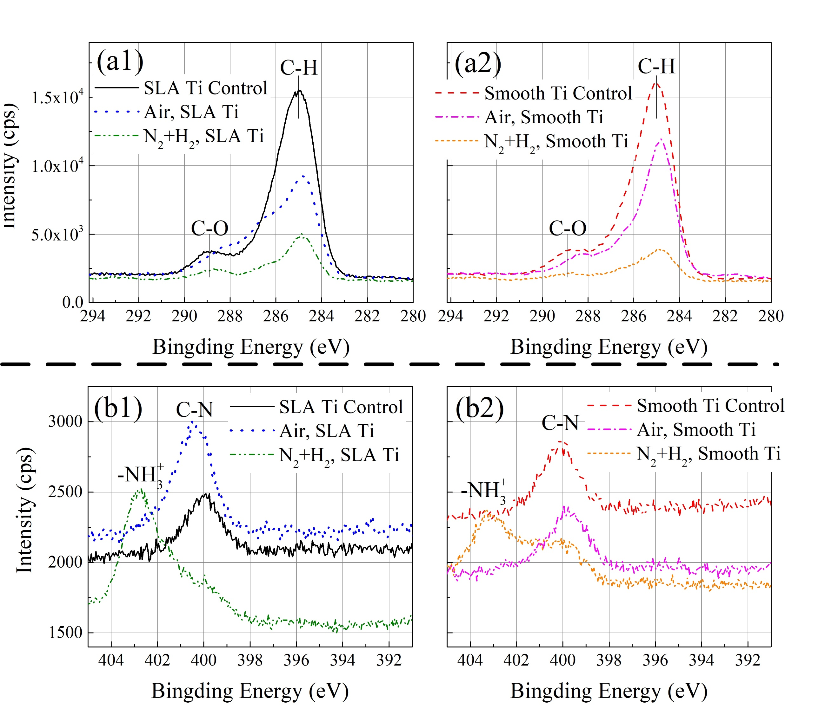
SEM was used to observe the surface morphology of titanium discs before and after plasma treatment. No obvious changes in surface morphology were detected. Therefore, the change in the properties of Ti was mainly attributed to surface chemical modification rather than morphological alteration. XPS analysis further confirmed this interpretation as shown in Fig.5. After N₂+H₂ plasma treatment, the C 1s signal decreased, indicating that organic carbon contaminants were removed from the titanium surface. At the same time, nitrogen-containing functional groups were introduced, as shown by the appearance of an N 1s component assigned to amino-related groups such as –NH₃⁺. These chemical changes explain the strong increase in hydrophilicity: removal of hydrophobic carbon contamination exposes a cleaner titanium surface, while polar nitrogen-containing groups increase surface energy and improve interaction with water.
Figure 5: Chemical composition of titanium samples measured by high-resolution XPS. (a) C 1s spectra. (b) N 1s spectra. (x1) for SLA Ti. (x2) for Smooth Ti.
Among the tested surfaces, plasma-treated smooth titanium is particularly noteworthy. Untreated smooth titanium has relatively poor cell adhesion, but after N₂+H₂ plasma treatment it exhibited strong hydrophilicity, more than four-log antibacterial performance, and improved cell adhesion. Since smooth titanium is simpler and less expensive than roughened SLA titanium, plasma-modified smooth titanium may provide a practical balance between biological performance and material cost.
References
- C. Karthik, S.C. Sarngadharan and V. Thomas, International Jornal of Molecular Sciences 25, 1(2024).
- I. Han, B.J. Kwon, B. Vagaska, B.J. Kim, J.K. Kang, M.H. Lee, H.H. Kim, J.C. Park, K.K. Wang, Y.R. Kim, J.S. An, J.M. Lee, C.Y. Hyun, J.H. Jeong and S.J. Lim, Macromolecular Research 19, 11(2011).

