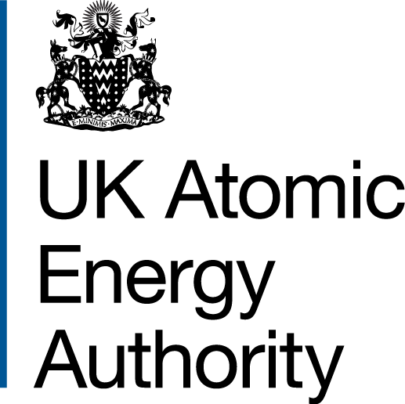
Photography & Filming Release Form

THIS FORM MUST BE COMPLETED BEFORE ANY PHOTOGRAPHY OR FILMING IS UNDERTAKEN.

Purpose of this form
The UK Atomic Energy Authority would like your permission to photograph/film your child for purposes such as promotional material, educational use, social media, or for use on our website.

As the parent or legal guardian, I hereby give the UK Atomic Energy Authority permission to:

- Photograph, film, or otherwise record the voice and likeness of my child for the purposes of the production, whether by film, video, digital recording, or other means.

- Make copies and use the photographs or recordings taken for the purposes of education, promotion, publicity, or advertising related to UKAEA activities.

- Use my child’s name and likeness in connection with these materials across all forms of media and future public relations or educational projects

I understand and agree that:

- No financial compensation will be provided for the use of these images, recordings, or likeness.

- All materials and recordings remain the property of the UK Atomic Energy Authority.
- There will be no restrictions on how many times or where these materials may be used.
- Consent can be withdrawn at any time by contacting: creativerequests@ukaea.uk

Student Details
Full Name (please print): |  | D.O.B: | / /
School / College:
Signature:

Parent/Guardian Details
Full Name (please print): |  | D.O.B: | / /
Relationship to Student:
Signature:

