
Welcome to UKAEA’s 17th Suppliers’ Event!

Please see below for directions around Culham Campus for this event.
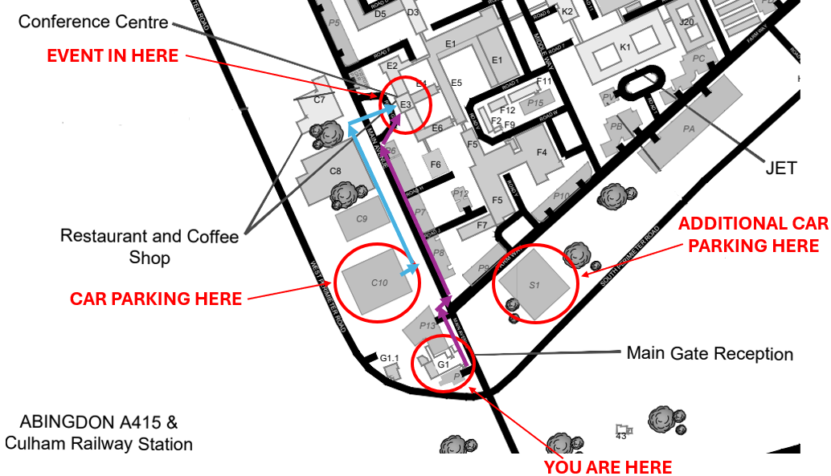
Directions for Drivers (blue arrows on map):
- Drive through the barriers of main gate showing your pass
- Carry on straight over the mini roundabout
- Turn left into the first car park – there should be signage posted outside
- Once you have parked your car, follow the path left out of the car park and carry on walking until you reach a zebra crossing in your right
- Cross over the zebra crossing straight into the building in front of you where, once inside, you should see Costa – signage will be posted outside the entrance
- Follow the signage up the stairs to the venue

Directions for Attendees Walking (purple arrows on map):
- Walk through the barriers of main gate showing your pass
- Follow the path in front of you until you reach the zebra crossing on your right
- Cross the road and follow the path on your left straight down the main road
- The path should turn slightly right into the building where Costa will be inside – signage should be posted outside the entrance
- Follow the signage up the stairs to the venue

UKAEA staff will be around throughout the event to direct you, support and answer any questions you may have.

Please ensure that when you leave, you return you visitor pass at the gate. Thank you for joining us!

